Paraboloid

Definition
# Source: AI Source: Provided by: [Data Path: Persons Table -> ID Column: 1, Name_En Column: Motasem Essam] -> From: [ChatGPT] on [7/25/2026]
A paraboloid is a three-dimensional geometric surface generated by a parabola moving or extending through space according to a particular geometric rule. It has a curved surface and is commonly classified into two main types:
- Elliptic Paraboloid
- Hyperbolic Paraboloid
A paraboloid is a quadric surface because its equation is a second-degree equation in three variables.

Simple Definition
# Source: AI Source: Provided by: [Data Path: Persons Table -> ID Column: 1, Name_En Column: Motasem Essam] -> From: [ChatGPT] on [7/25/2026]
A paraboloid is a three-dimensional solid-like shape with a curved surface based on a parabola.
- An elliptic paraboloid resembles a bowl or satellite dish.
- A hyperbolic paraboloid resembles a saddle.
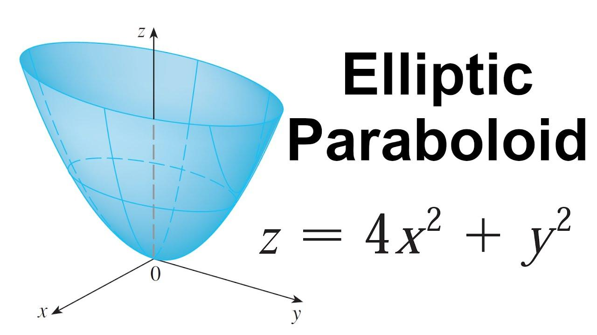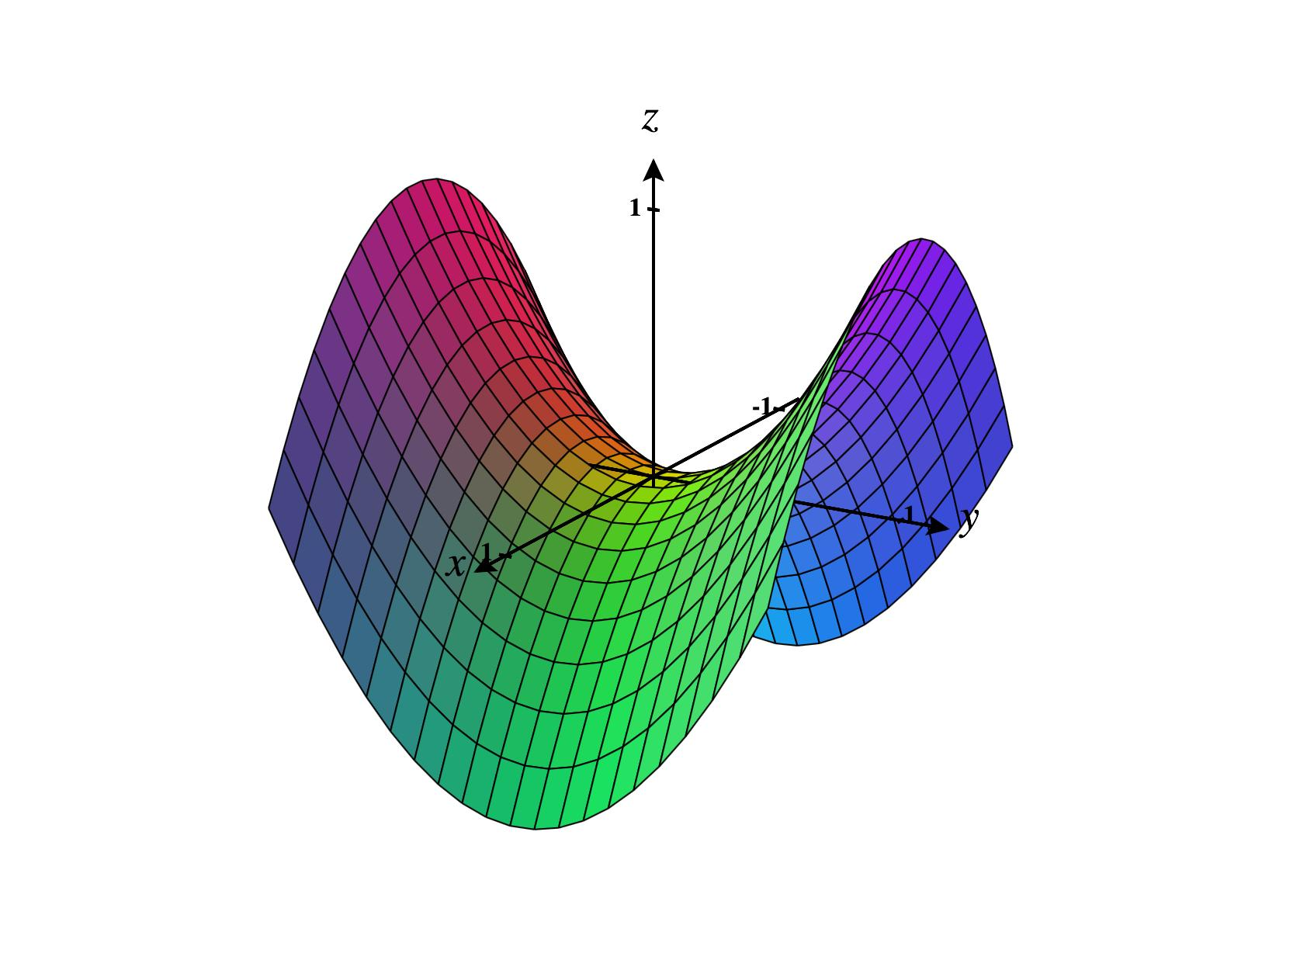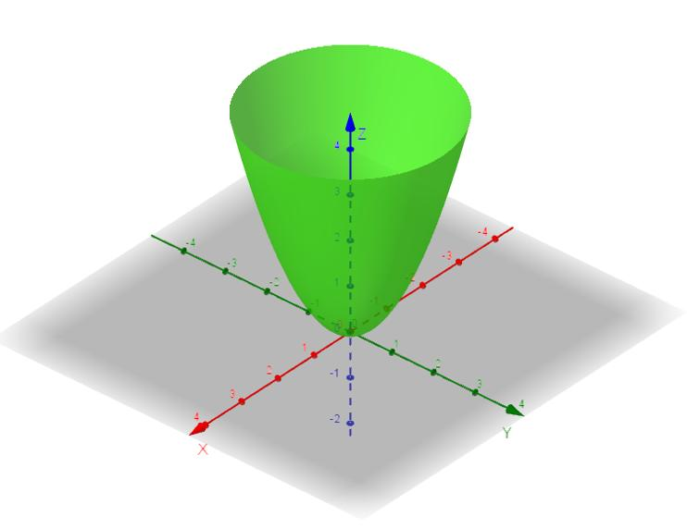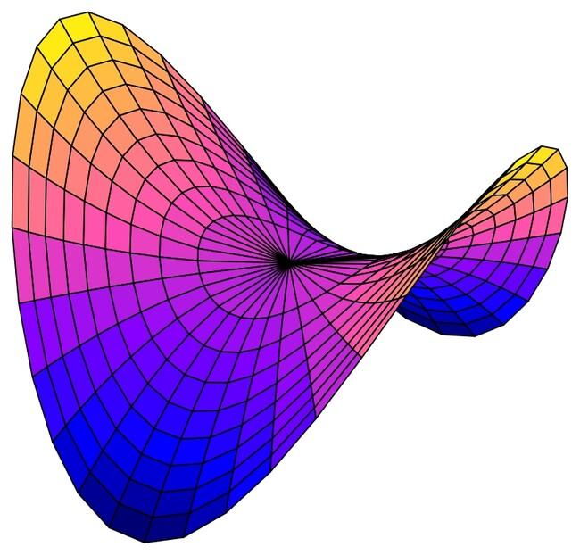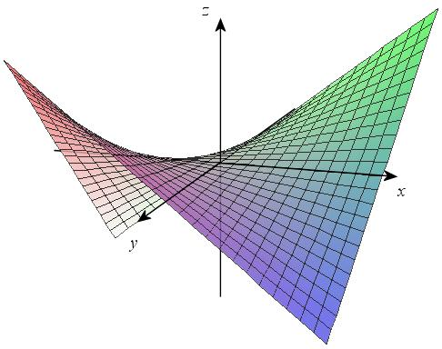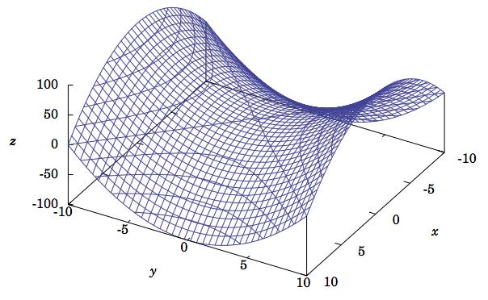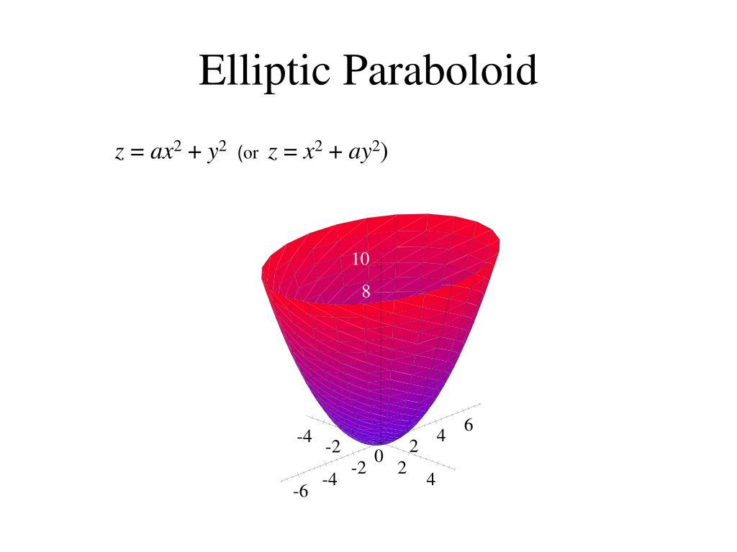
Note: A paraboloid technically describes a surface. The solid enclosed by the surface and a cutting plane is called a paraboloid segment or paraboloidal solid, depending on the context.

Geometric Structure
# Source: AI Source: Provided by: [Data Path: Persons Table -> ID Column: 1, Name_En Column: Motasem Essam] -> From: [ChatGPT] on [7/25/2026]
A paraboloid is generally described using three-dimensional Cartesian coordinates:
- Vertex: The point where the paraboloid reaches its minimum, maximum, or saddle position.
- Axis: The principal direction of the paraboloid's symmetry, when it has one.
- Apex: Sometimes used for the vertex of an elliptic paraboloid.
- Cross-section: A two-dimensional curve produced by intersecting the surface with a plane.
- Opening direction: The direction in which the surface extends from its vertex.

Main Classification
# Source: AI Source: Provided by: [Data Path: Persons Table -> ID Column: 1, Name_En Column: Motasem Essam] -> From: [ChatGPT] on [7/25/2026]
Paraboloids are classified into two principal types.

Elliptic Paraboloid
# Source: AI Source: Provided by: [Data Path: Persons Table -> ID Column: 1, Name_En Column: Motasem Essam] -> From: [ChatGPT] on [7/25/2026]
An elliptic paraboloid is a paraboloid whose horizontal cross-sections are ellipses or circles.
Its standard equation is:
$$z=\frac{x^{2}}{a^{2}}+\frac{y^{2}}{b^{2}}$$
Where:
- $a$ = horizontal scale parameter along the x-axis.
- $b$ = horizontal scale parameter along the y-axis.
- $x,y,z$ = Cartesian coordinates.
Characteristics:
- Has one vertex.
- Has a single axis of symmetry.
- Opens upward in the standard equation.
- Horizontal cross-sections are ellipses.
- Vertical cross-sections through the axis are parabolas.
- If $a=b$, the horizontal cross-sections are circles, producing a circular paraboloid.
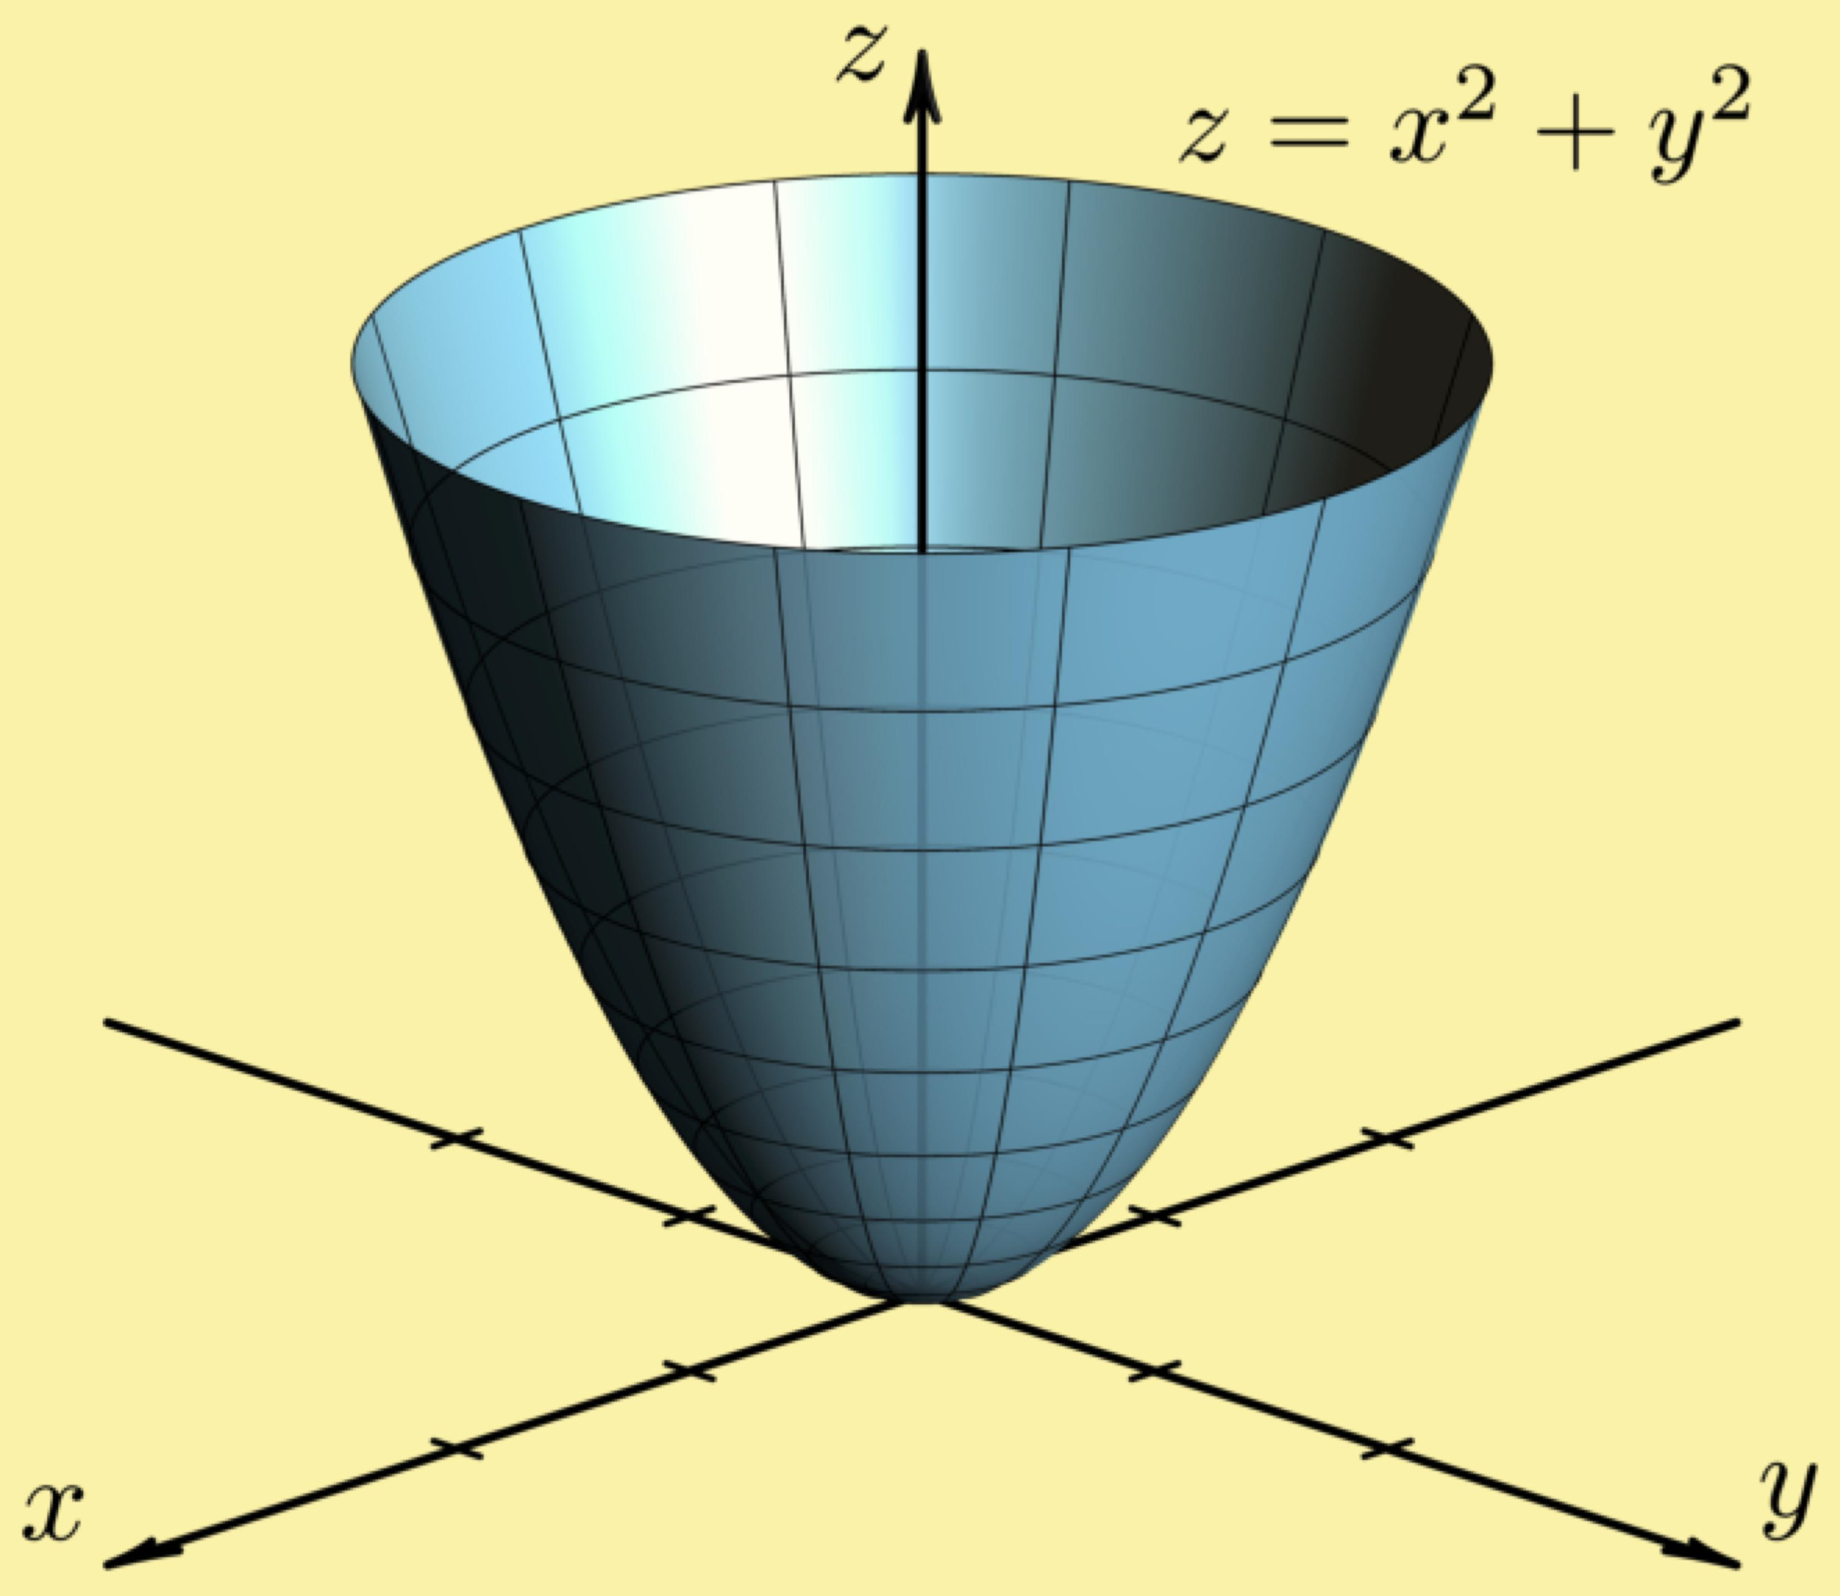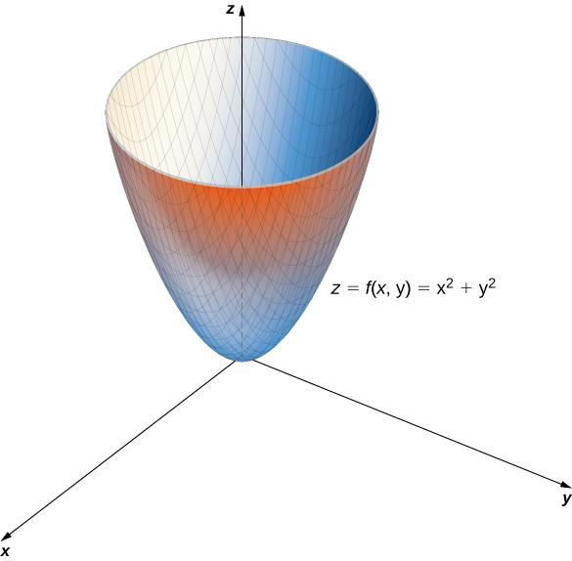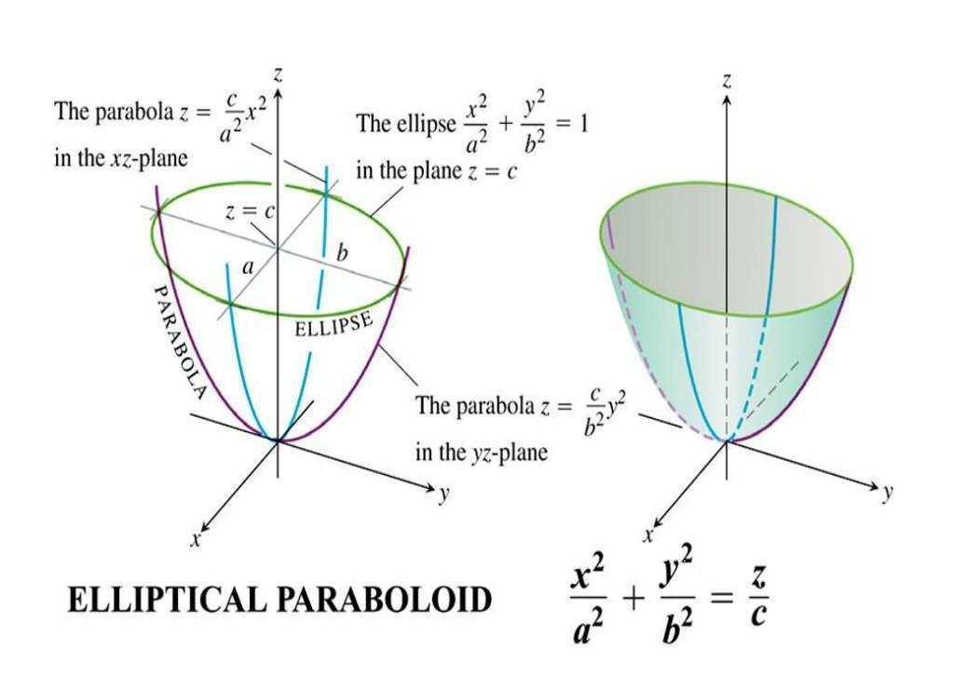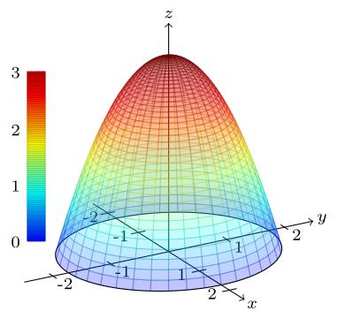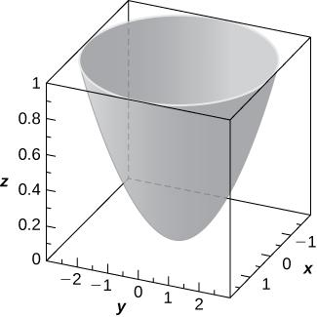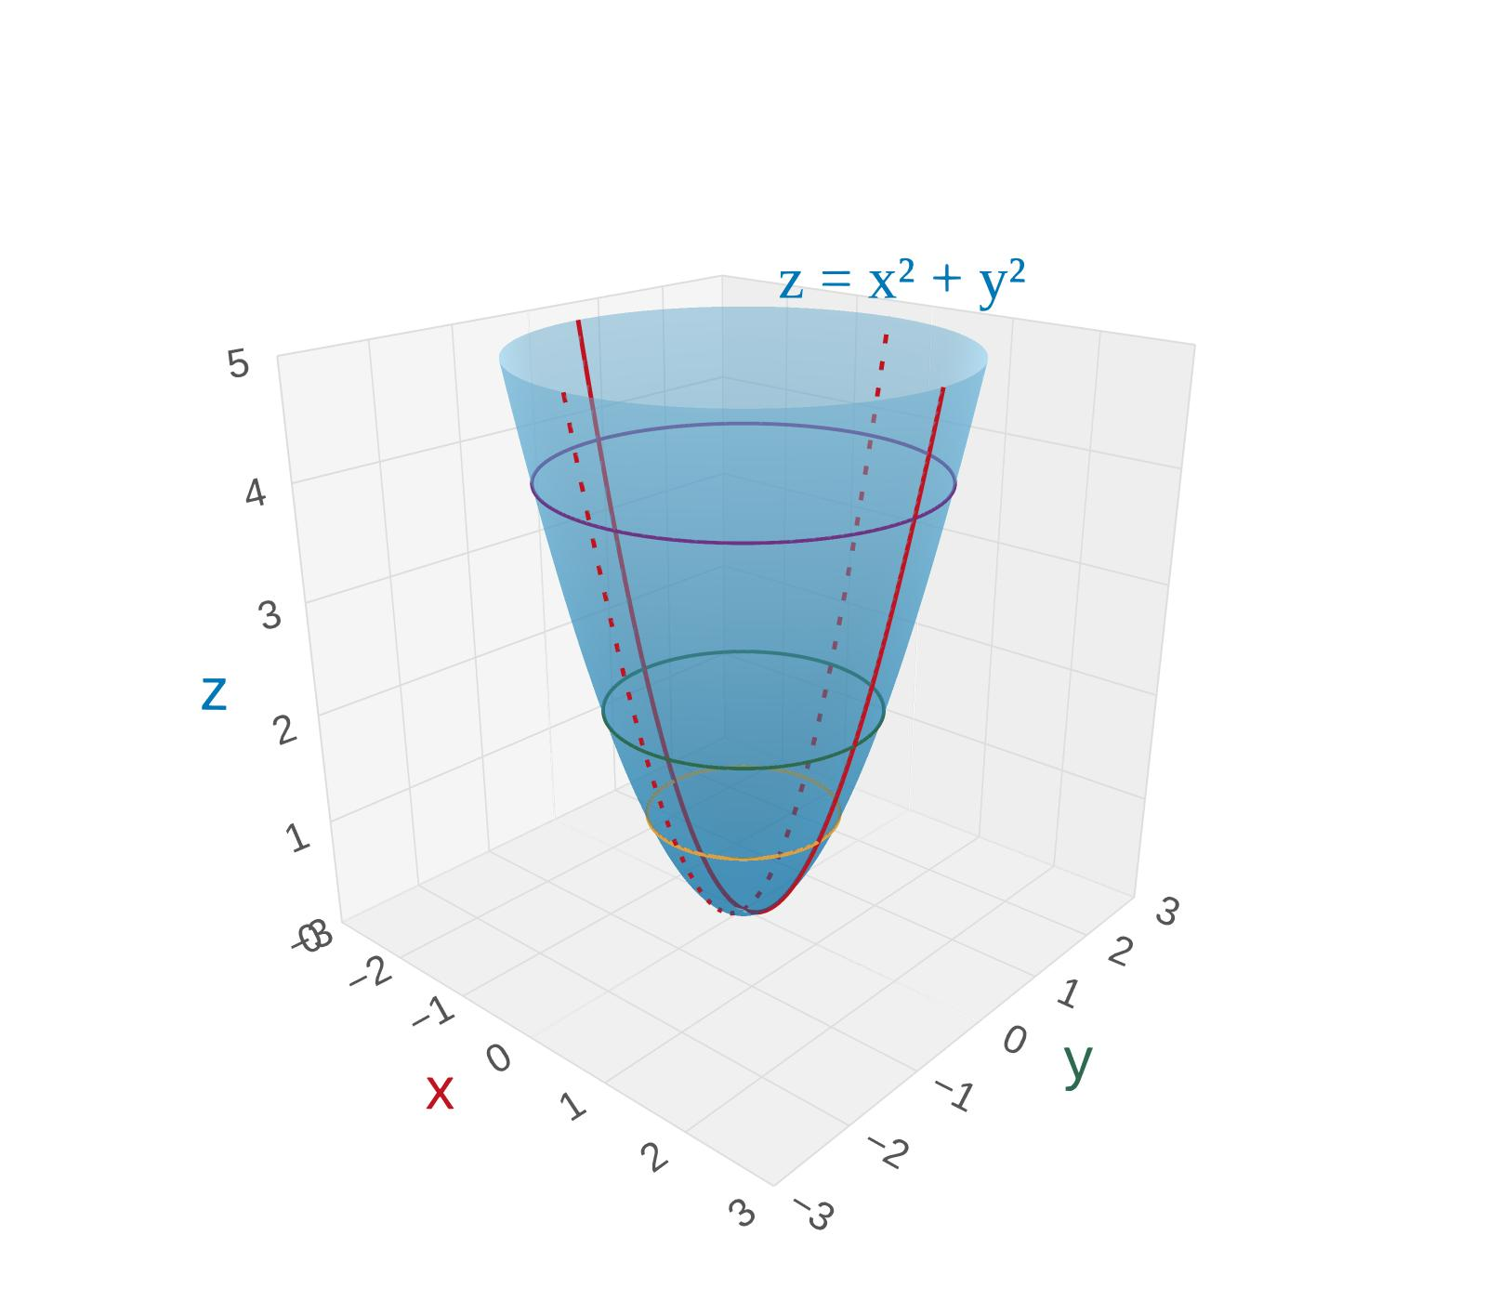

Types of Elliptic Paraboloids
# Source: AI Source: Provided by: [Data Path: Persons Table -> ID Column: 1, Name_En Column: Motasem Essam] -> From: [ChatGPT] on [7/25/2026]
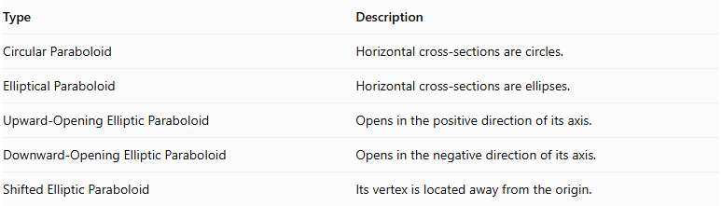
Type | Description
Circular Paraboloid | Horizontal cross-sections are circles.
Elliptical Paraboloid | Horizontal cross-sections are ellipses.
Upward-Opening Elliptic Paraboloid | Opens in the positive direction of its axis.
Downward-Opening Elliptic Paraboloid | Opens in the negative direction of its axis.
Shifted Elliptic Paraboloid | Its vertex is located away from the origin.

Hyperbolic Paraboloid
# Source: AI Source: Provided by: [Data Path: Persons Table -> ID Column: 1, Name_En Column: Motasem Essam] -> From: [ChatGPT] on [7/25/2026]
A hyperbolic paraboloid is a saddle-shaped surface whose horizontal cross-sections are hyperbolas, while certain vertical cross-sections are parabolas.
Its standard equation is:
$$z=\frac{x^{2}}{a^{2}}-\frac{y^{2}}{b^{2}}$$
Where:
- $a$ = scale parameter along the x-axis.
- $b$ = scale parameter along the y-axis.
- $x,y,z$ = Cartesian coordinates.
Characteristics:
- Has a saddle-shaped surface.
- Has a saddle point at its vertex.
- Curves upward in one principal direction.
- Curves downward in the perpendicular principal direction.
- Horizontal cross-sections are generally hyperbolas.
- Vertical cross-sections parallel to the principal coordinate planes are parabolas.
- It has no single opening direction like an elliptic paraboloid.
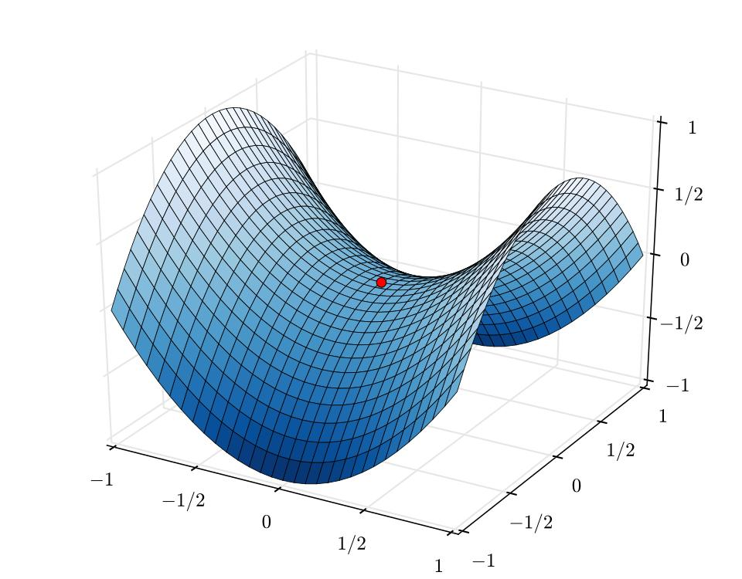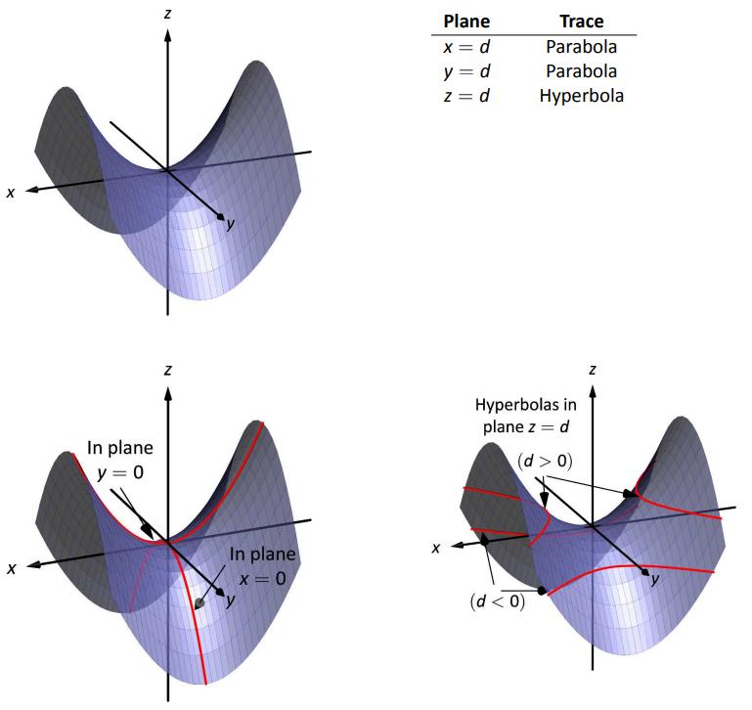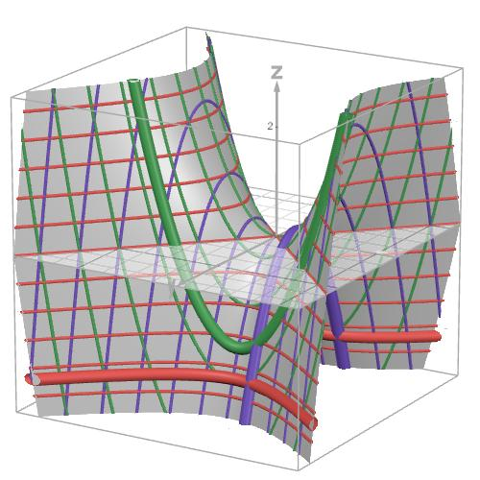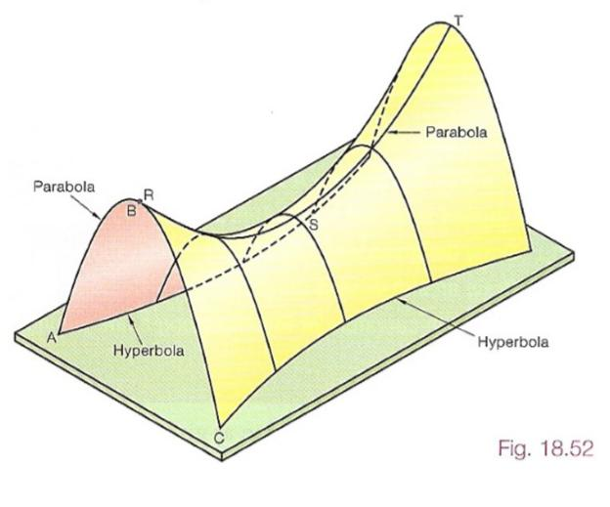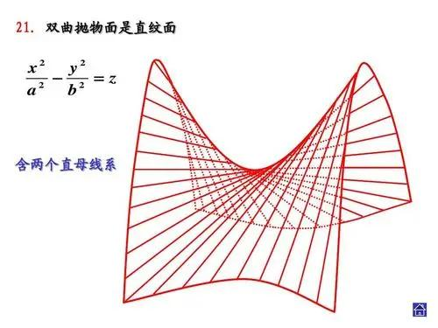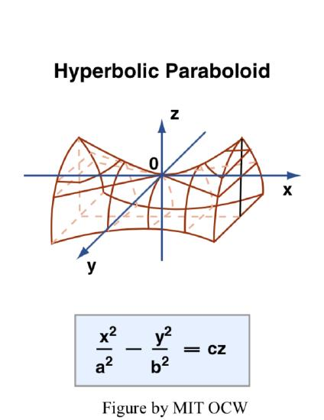

Types of Hyperbolic Paraboloids
# Source: AI Source: Provided by: [Data Path: Persons Table -> ID Column: 1, Name_En Column: Motasem Essam] -> From: [ChatGPT] on [7/25/2026]
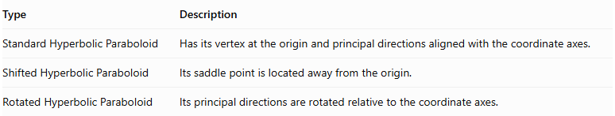
Type | Description
Standard Hyperbolic Paraboloid | Has its vertex at the origin and principal directions aligned with the coordinate axes.
Shifted Hyperbolic Paraboloid | Its saddle point is located away from the origin.
Rotated Hyperbolic Paraboloid | Its principal directions are rotated relative to the coordinate axes.

Classification by Opening Direction
# Source: AI Source: Provided by: [Data Path: Persons Table -> ID Column: 1, Name_En Column: Motasem Essam] -> From: [ChatGPT] on [7/25/2026]
This classification mainly applies to elliptic paraboloids.
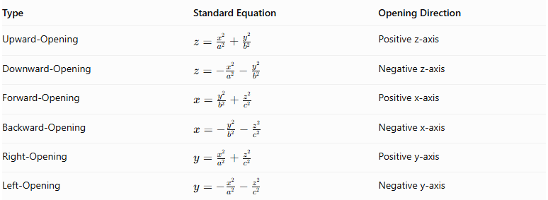
Type | Standard Equation | Opening Direction
Upward-Opening | $$z=\frac{x^{2}}{a^{2}}+\frac{y^{2}}{b^{2}}$$ | Positive z-axis
Downward-Opening | $$z=-\frac{x^{2}}{a^{2}}-\frac{y^{2}}{b^{2}}$$ | Negative z-axis
Forward-Opening | $$x=\frac{y^{2}}{b^{2}}+\frac{z^{2}}{c^{2}}$$ | Positive x-axis
Backward-Opening | $$x=-\frac{y^{2}}{b^{2}}-\frac{z^{2}}{c^{2}}$$ | Negative x-axis
Right-Opening | $$y=\frac{x^{2}}{a^{2}}+\frac{z^{2}}{c^{2}}$$ | Positive y-axis
Left-Opening | $$y=-\frac{x^{2}}{a^{2}}-\frac{z^{2}}{c^{2}}$$ | Negative y-axis
Forward/backward and right/left depend on the coordinate convention being used. The positive or negative axis is the mathematically precise description.

Mathematical Properties and Formulas

Elliptic Paraboloid
# Source: AI Source: Provided by: [Data Path: Persons Table -> ID Column: 1, Name_En Column: Motasem Essam] -> From: [ChatGPT] on [7/25/2026]
For:
$$z=\frac{x^{2}}{a^{2}}+\frac{y^{2}}{b^{2}}$$
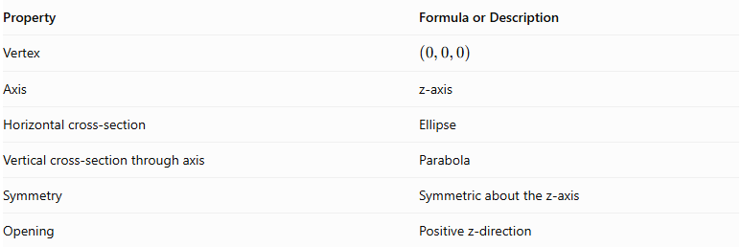
Property | Formula or Description
Vertex | $$(0,0,0)$$
Axis | z-axis
Horizontal cross-section | Ellipse
Vertical cross-section through axis | Parabola
Symmetry | Symmetric about the z-axis
Opening | Positive z-direction
For a circular paraboloid, where $a=b$:
$$z=\frac{x^{2}+y^{2}}{a^{2}}$$

Hyperbolic Paraboloid
# Source: AI Source: Provided by: [Data Path: Persons Table -> ID Column: 1, Name_En Column: Motasem Essam] -> From: [ChatGPT] on [7/25/2026]
For:
$$z=\frac{x^{2}}{a^{2}}-\frac{y^{2}}{b^{2}}$$
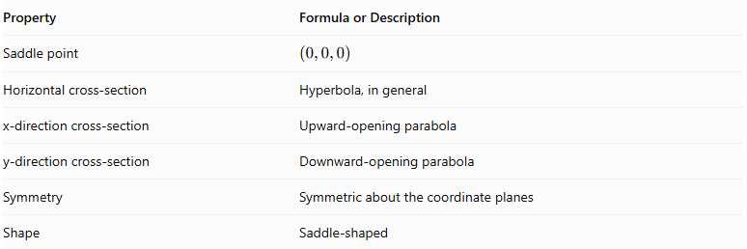
Property | Formula or Description
Saddle point | $$(0,0,0)$$
Horizontal cross-section | Hyperbola, in general
x-direction cross-section | Upward-opening parabola
y-direction cross-section | Downward-opening parabola
Symmetry | Symmetric about the coordinate planes
Shape | Saddle-shaped

Volume of a Paraboloid Segment
# Source: AI Source: Provided by: [Data Path: Persons Table -> ID Column: 1, Name_En Column: Motasem Essam] -> From: [ChatGPT] on [7/25/2026]
For an elliptic paraboloid cut by a plane parallel to its base, with:
- $h$ = height of the segment.
- $a$ = semi-major radius of the elliptical base.
- $b$ = semi-minor radius of the elliptical base.
The volume is:
$$\boxed{V=\frac{1}{2}πabh}$$
For a circular paraboloid, where $a=b=r$:
$$\boxed{V=\frac{1}{2}πr^{2}h}$$
This formula applies to the solid between the vertex and a plane perpendicular to the paraboloid's axis.

Curved Surface Area
# Source: AI Source: Provided by: [Data Path: Persons Table -> ID Column: 1, Name_En Column: Motasem Essam] -> From: [ChatGPT] on [7/25/2026]
The curved surface area of an elliptic paraboloid generally requires integration. It does not have one simple universal formula like the volume formula.
For a circular paraboloid described by:
$$z=\frac{r^{2}}{4f}$$
where $f$ is the focal length, its curved surface area up to radius $R$ is:
$$CSA=\frac{π}{6f^{2}}[(R^{2}+4f^{2})^{3/2}-8f^{3}]$$
The total surface area of a closed paraboloidal segment also includes its flat elliptical or circular base.

Worked Examples

Example 1: Volume of a Circular Paraboloid
# Source: AI Source: Provided by: [Data Path: Persons Table -> ID Column: 1, Name_En Column: Motasem Essam] -> From: [ChatGPT] on [7/25/2026]
Given:
- Base radius: $r=6 cm$
- Height: $h=8 cm$
Formula:
$$V=\frac{1}{2}πr^{2}h$$
Substitution:
$$V=\frac{1}{2}π(6)^{2}(8)$$
$$V=\frac{1}{2}π(36)(8)$$
$$V=144π$$
<badge color="success">Final Answer</badge>
$$\boxed{V≈452.39{ cm}^{3}}$$

Example 2: Volume of an Elliptic Paraboloid
# Source: AI Source: Provided by: [Data Path: Persons Table -> ID Column: 1, Name_En Column: Motasem Essam] -> From: [ChatGPT] on [7/25/2026]
Given:
- Semi-major radius: $a=5 cm$
- Semi-minor radius: $b=3 cm$
- Height: $h=10 cm$
Formula:
$$V=\frac{1}{2}πabh$$
Substitution:
$$V=\frac{1}{2}π(5)(3)(10)$$
$$V=75π$$
<badge color="success">Final Answer</badge>
$$\boxed{V≈235.62{ cm}^{3}}$$

Constructing a Paraboloid

Geometric Instruments
# Source: AI Source: Provided by: [Data Path: Persons Table -> ID Column: 1, Name_En Column: Motasem Essam] -> From: [ChatGPT] on [7/25/2026]
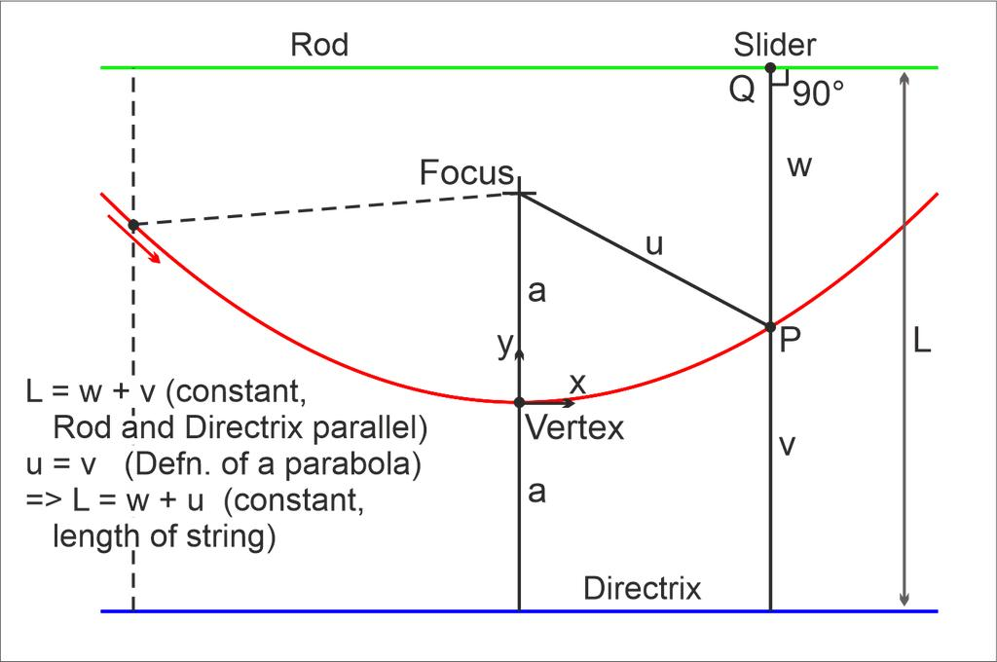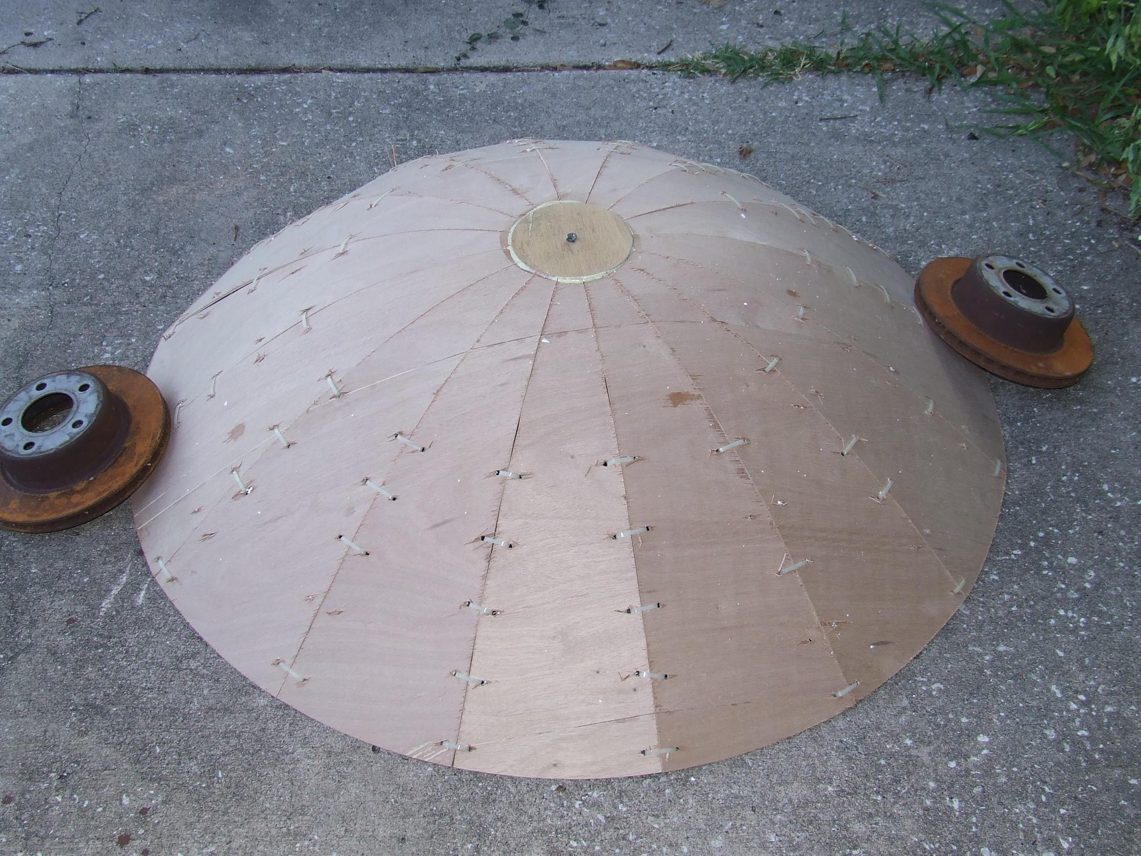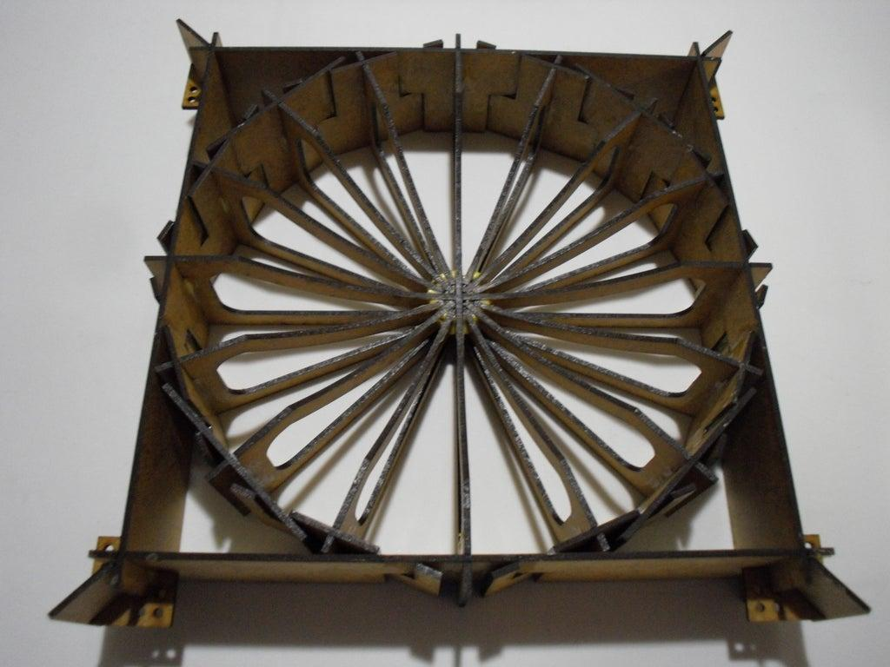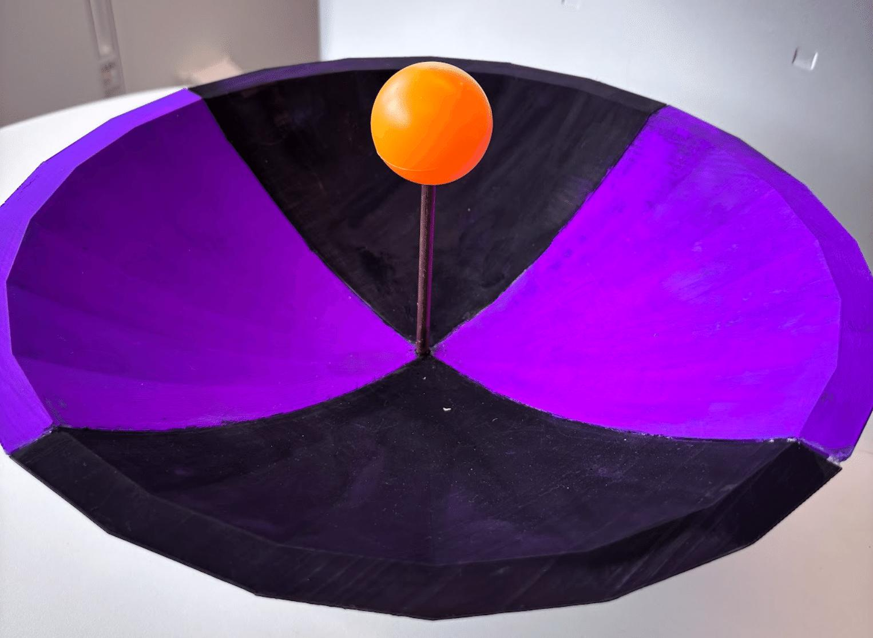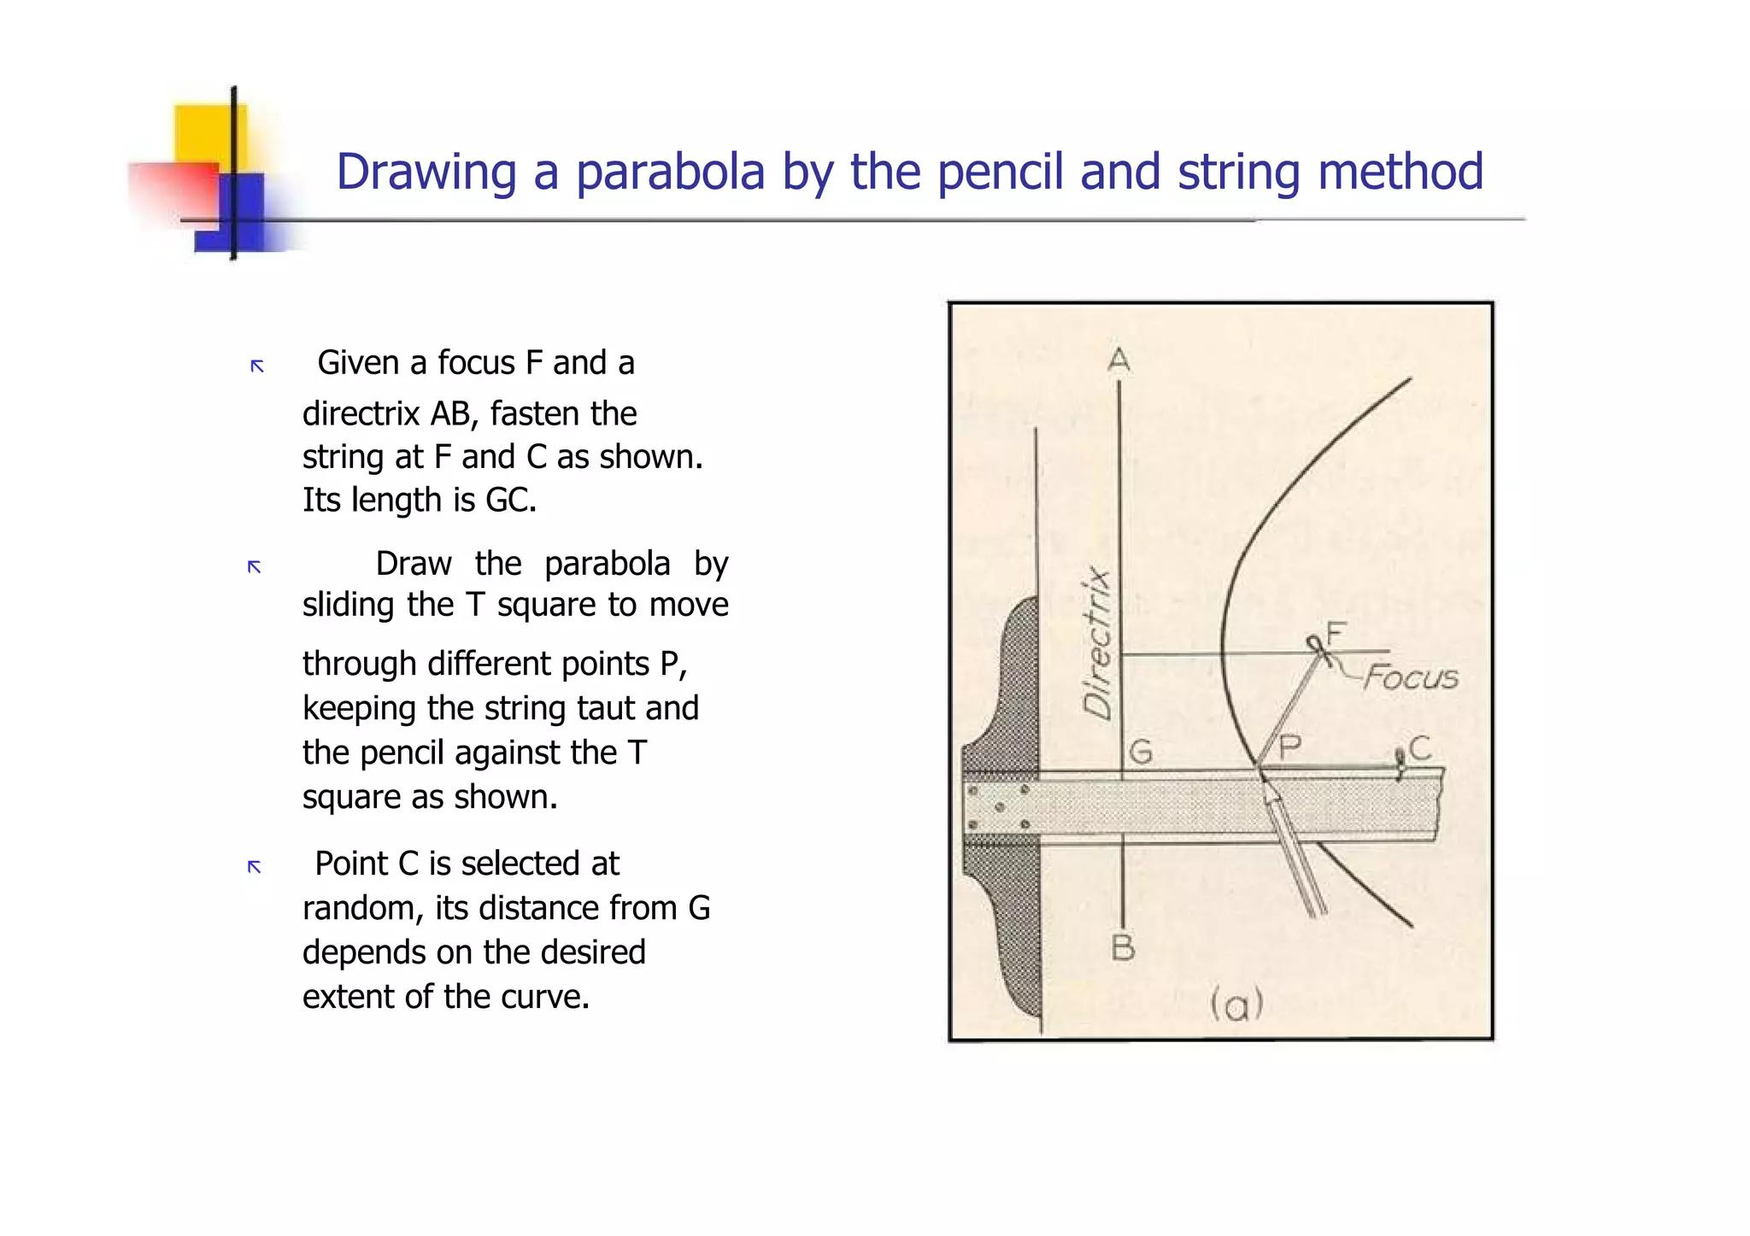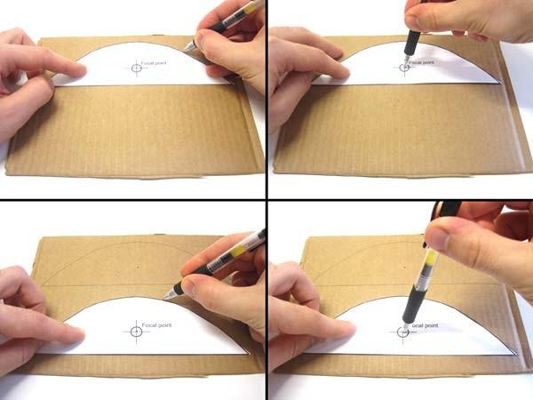
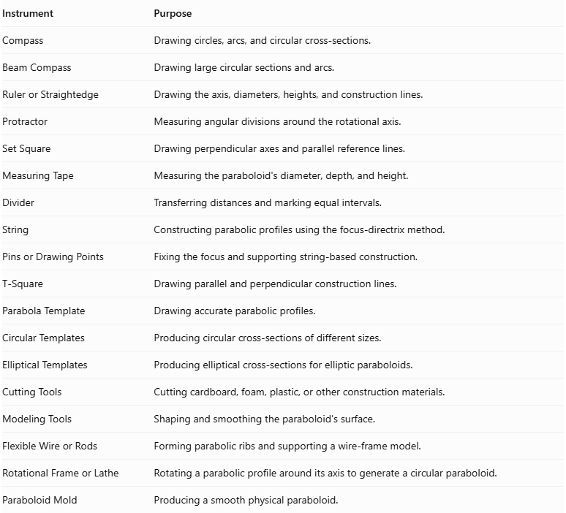
Instrument | Purpose
Compass | Drawing circles, arcs, and circular cross-sections.
Beam Compass | Drawing large circular sections and arcs.
Ruler or Straightedge | Drawing the axis, diameters, heights, and construction lines.
Protractor | Measuring angular divisions around the rotational axis.
Set Square | Drawing perpendicular axes and parallel reference lines.
Measuring Tape | Measuring the paraboloid's diameter, depth, and height.
Divider | Transferring distances and marking equal intervals.
String | Constructing parabolic profiles using the focus-directrix method.
Pins or Drawing Points | Fixing the focus and supporting string-based construction.
T-Square | Drawing parallel and perpendicular construction lines.
Parabola Template | Drawing accurate parabolic profiles.
Circular Templates | Producing circular cross-sections of different sizes.
Elliptical Templates | Producing elliptical cross-sections for elliptic paraboloids.
Cutting Tools | Cutting cardboard, foam, plastic, or other construction materials.
Modeling Tools | Shaping and smoothing the paraboloid's surface.
Flexible Wire or Rods | Forming parabolic ribs and supporting a wire-frame model.
Rotational Frame or Lathe | Rotating a parabolic profile around its axis to generate a circular paraboloid.
Paraboloid Mold | Producing a smooth physical paraboloid.

Instrument-Based Construction Procedures

Method 1: Constructing a Circular Paraboloid Using Rotational Symmetry
# Source: AI Source: Provided by: [Data Path: Persons Table -> ID Column: 1, Name_En Column: Motasem Essam] -> From: [ChatGPT] on [7/25/2026]
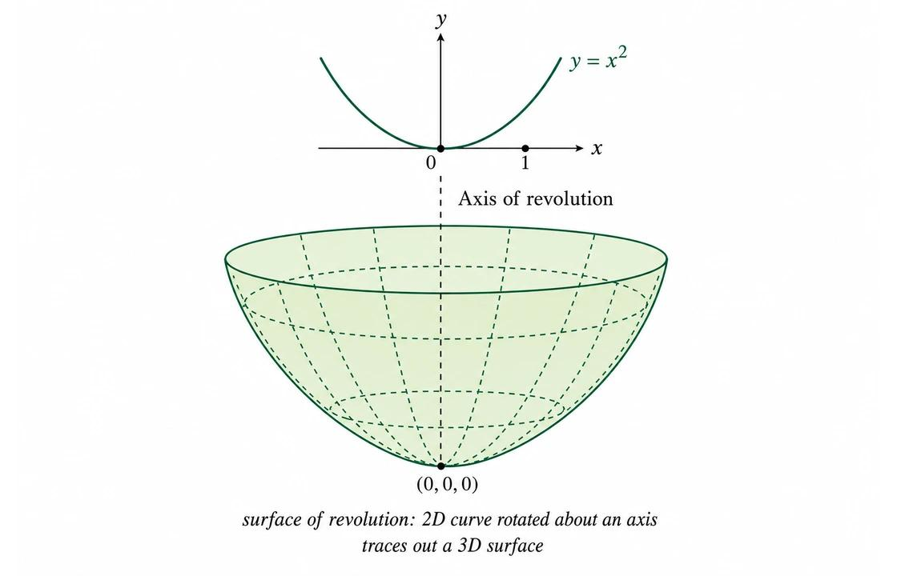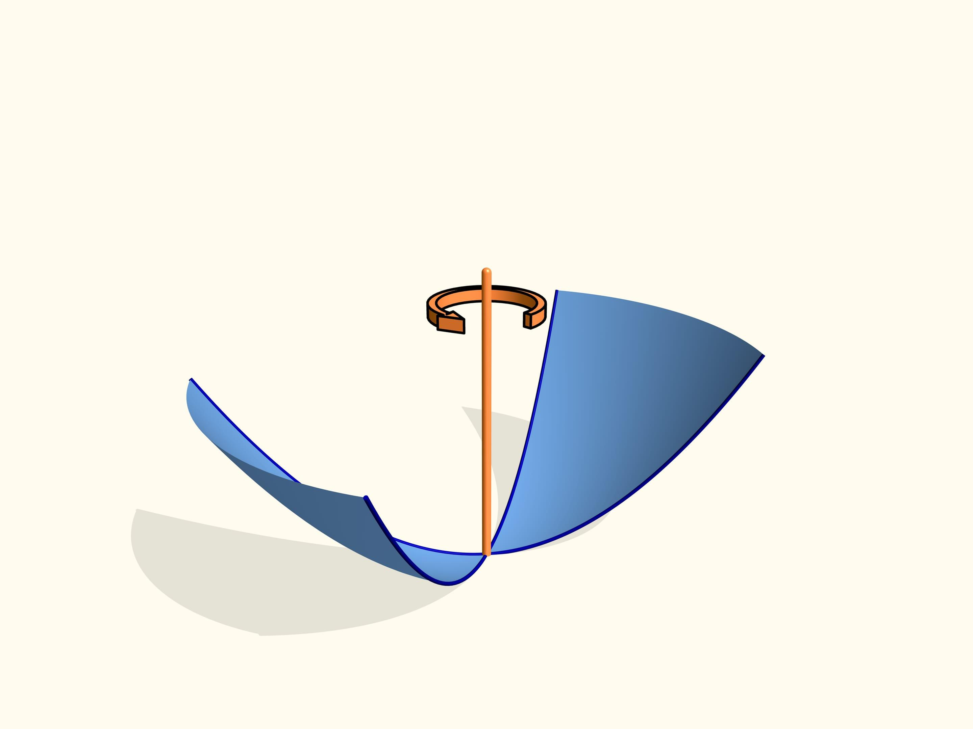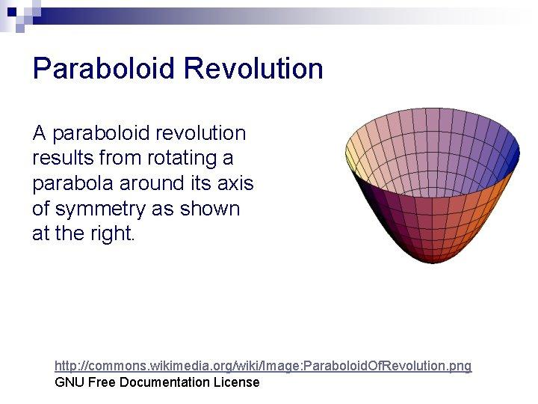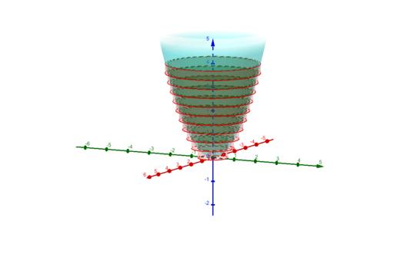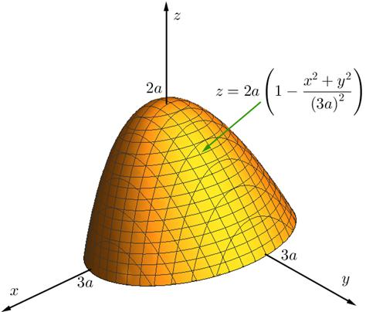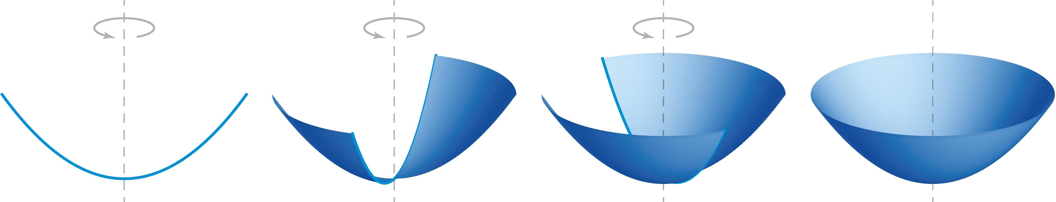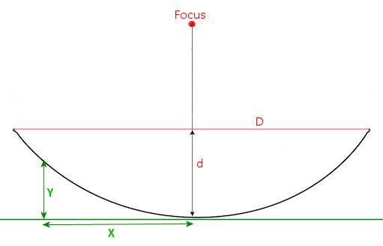
- Determine the required paraboloid's diameter and depth.
- Draw a vertical reference line representing the rotational axis.
- Construct a parabolic profile using the focus-directrix method.
- Ensure that the parabola's axis of symmetry coincides with the intended rotational axis.
- Draw the parabolic profile on cardboard, plastic, or another suitable material.
- Cut out the parabolic profile carefully.
- Attach the profile to a rotational frame along its axis of symmetry.
- Rotate the parabolic profile through a complete ${360}^{°}$ revolution.
- Observe the resulting circular paraboloidal surface.
- Use the rotating profile as a guide to shape a physical paraboloid.
- Smooth the surface and verify its diameter, depth, and symmetry.
Geometric principle: Rotating a parabola around its axis of symmetry generates a circular paraboloid.

Method 2: Constructing a Paraboloid Using Circular Cross-Sections
# Source: AI Source: Provided by: [Data Path: Persons Table -> ID Column: 1, Name_En Column: Motasem Essam] -> From: [ChatGPT] on [7/25/2026]
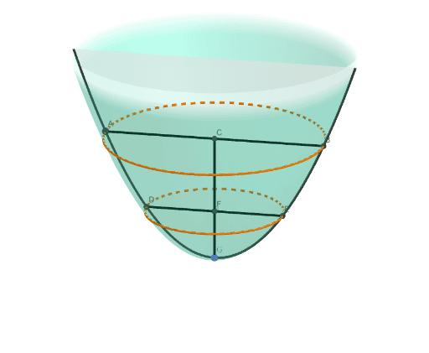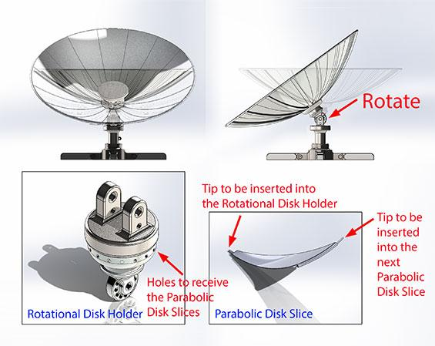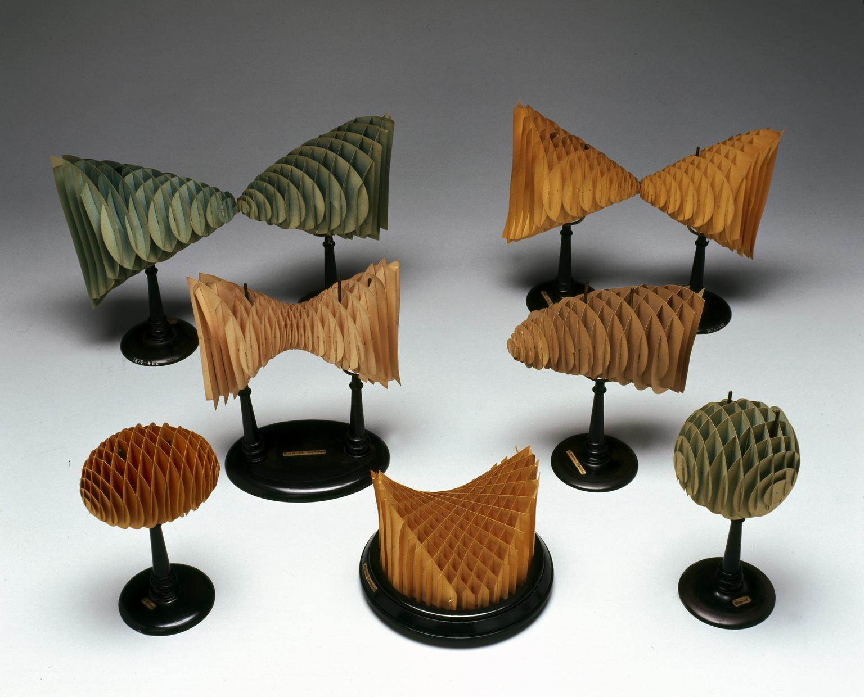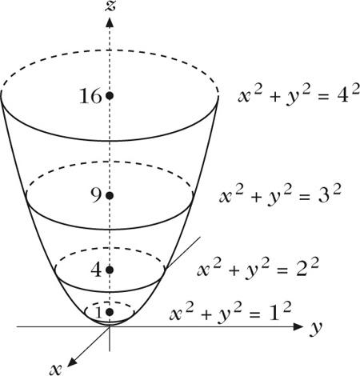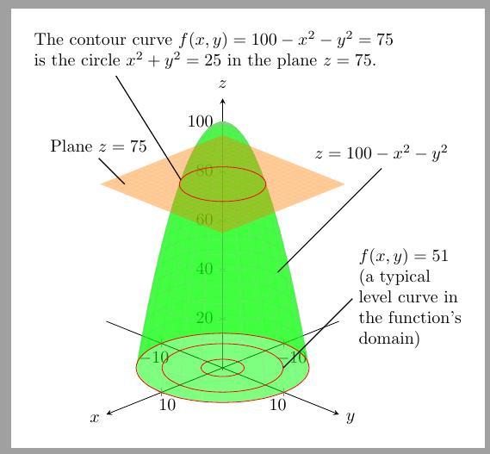
- Determine the required paraboloid's diameter and depth.
- Draw a vertical reference axis representing its axis of symmetry.
- Construct the parabolic side profile.
- Divide the paraboloid's height into several equal intervals.
- Draw perpendicular reference lines through the division points using a set square.
- Determine the radius of each circular cross-section from the parabolic profile.
- Draw the corresponding circles using a compass or circular templates.
- Cut the circular sections from cardboard, foam, or another suitable material.
- Arrange the circular sections perpendicular to the central axis.
- Align their centers along the axis.
- Arrange the smallest section near the vertex and progressively larger sections toward the opening.
- Join the sections using adhesive or a central support.
- Smooth the outer boundaries to approximate a continuous paraboloidal surface.

Method 3: Constructing a Paraboloid Using a Focus-Directrix Parabola Profile
# Source: AI Source: Provided by: [Data Path: Persons Table -> ID Column: 1, Name_En Column: Motasem Essam] -> From: [ChatGPT] on [7/25/2026]
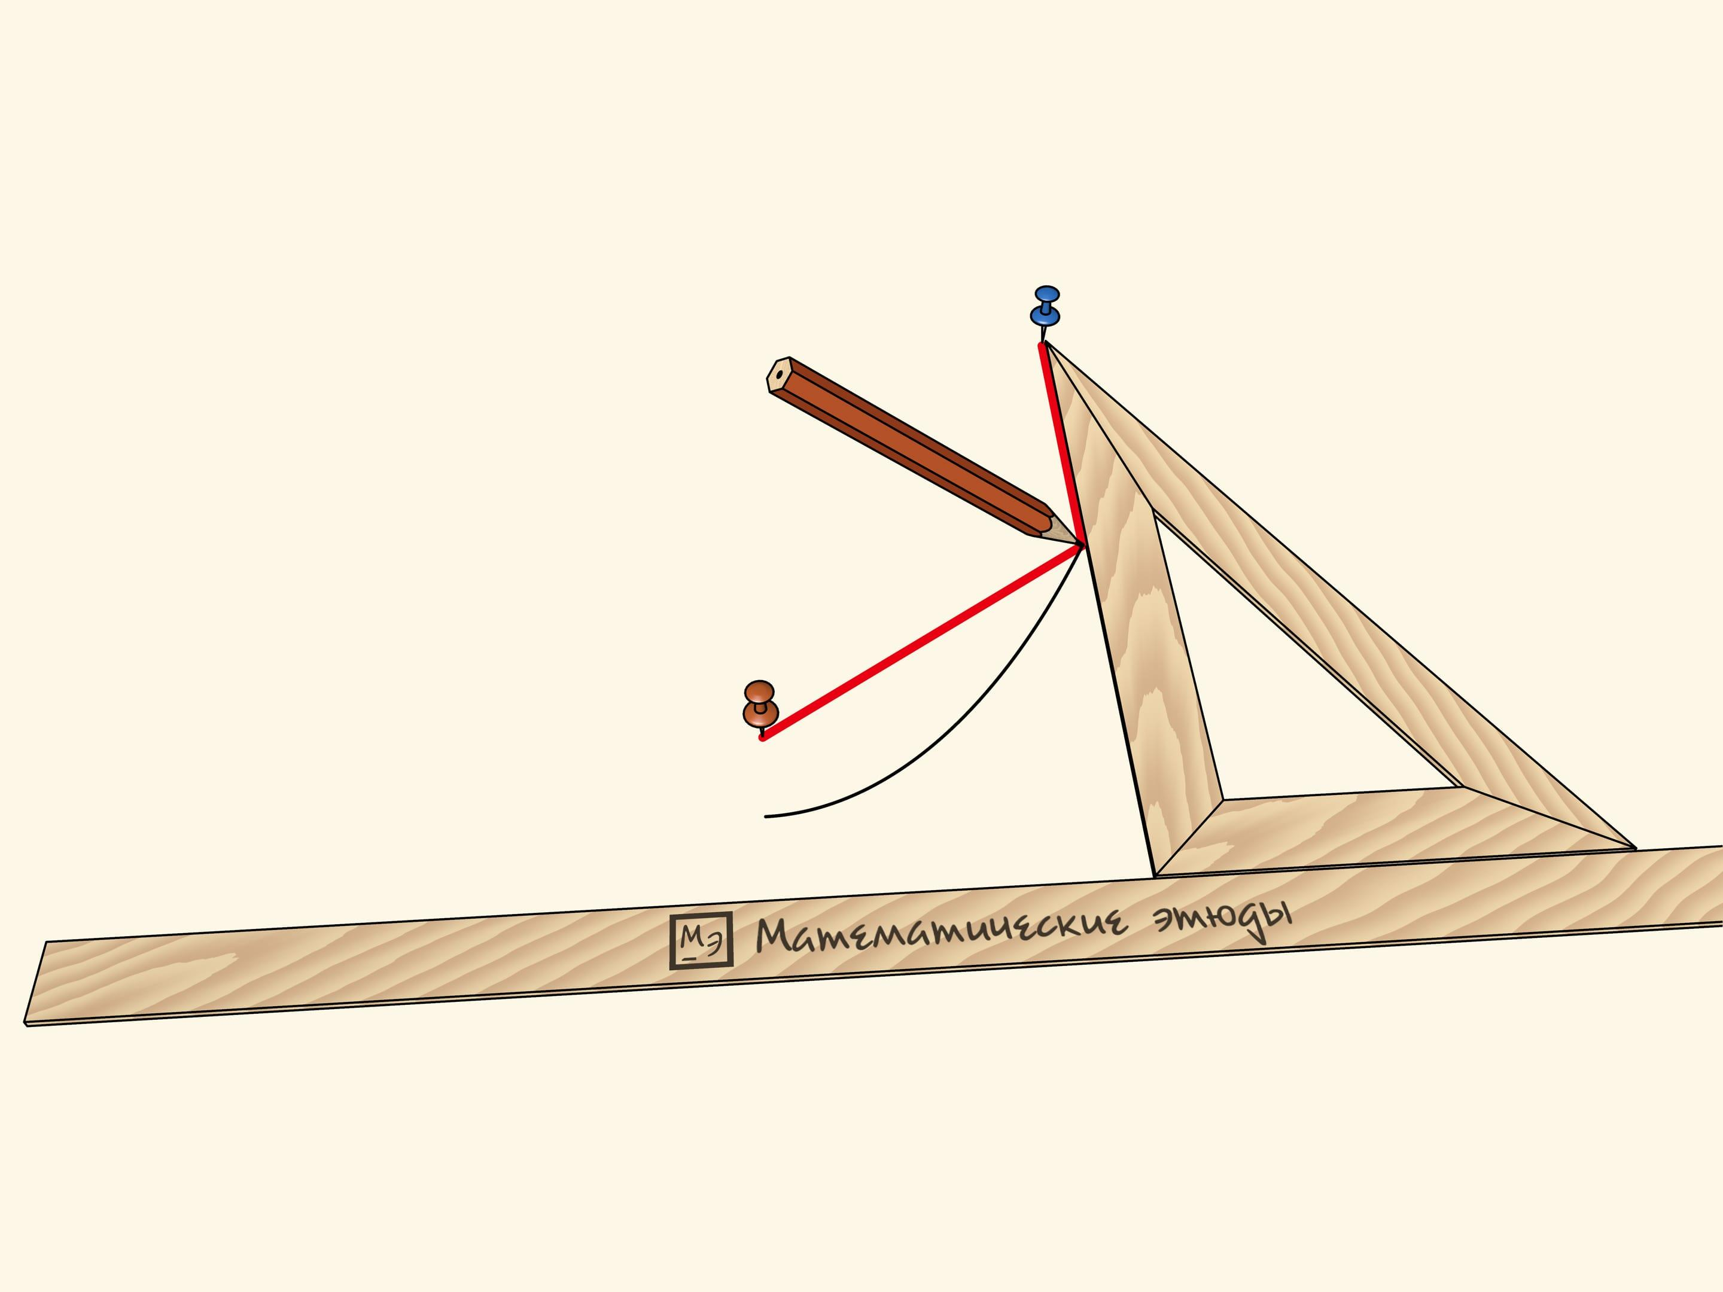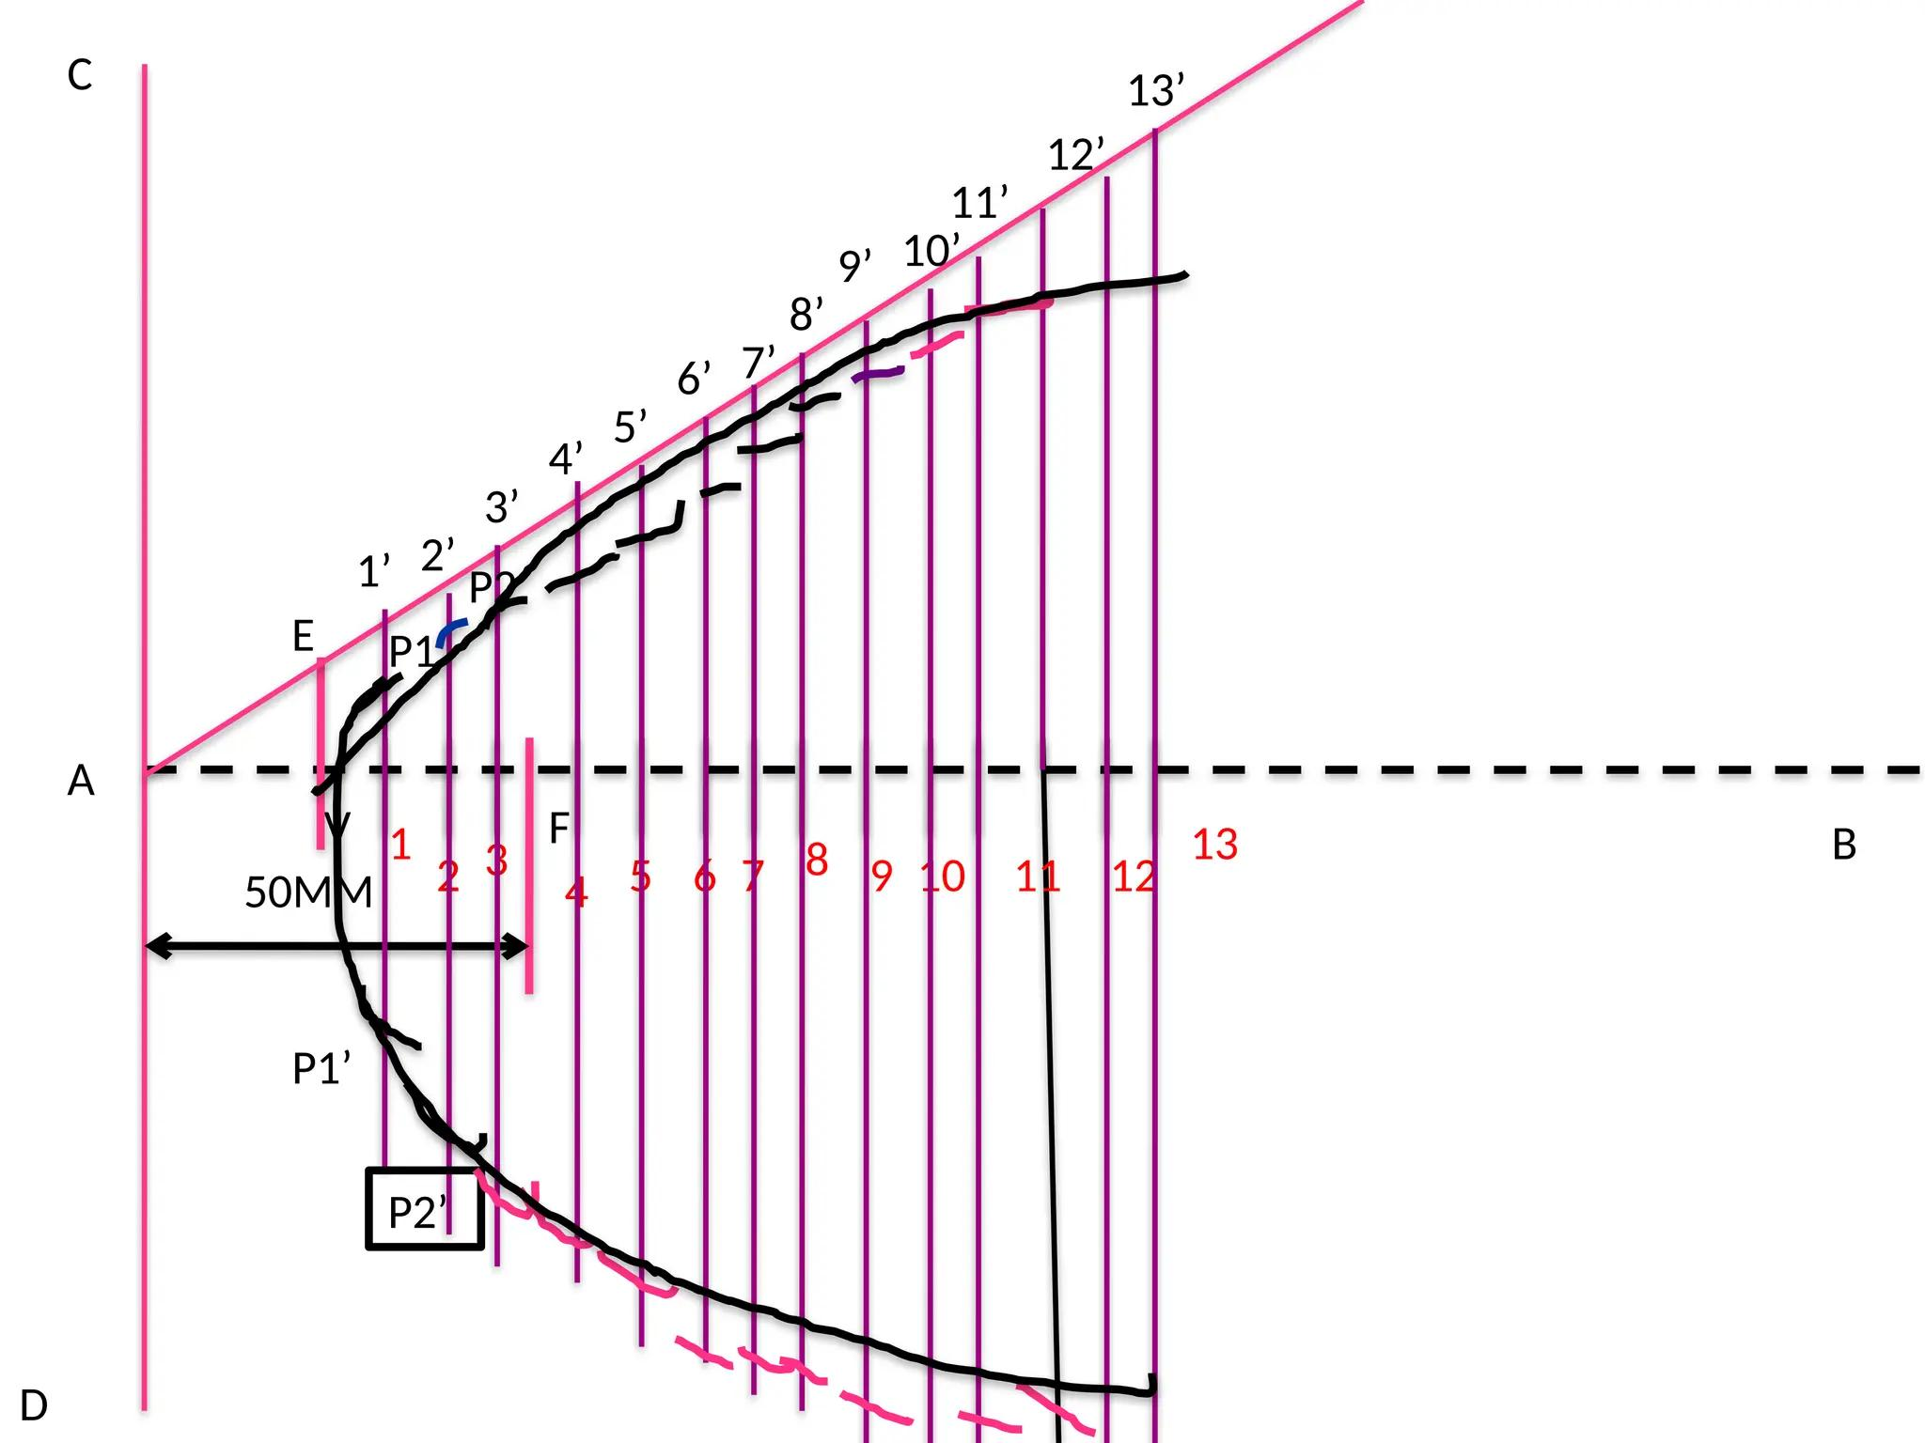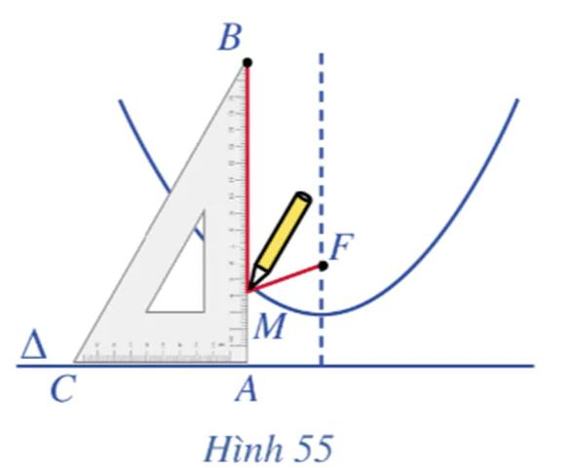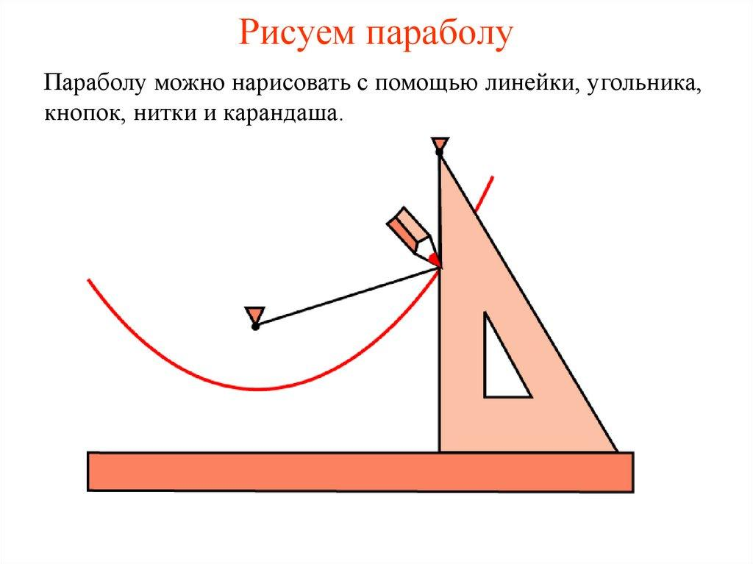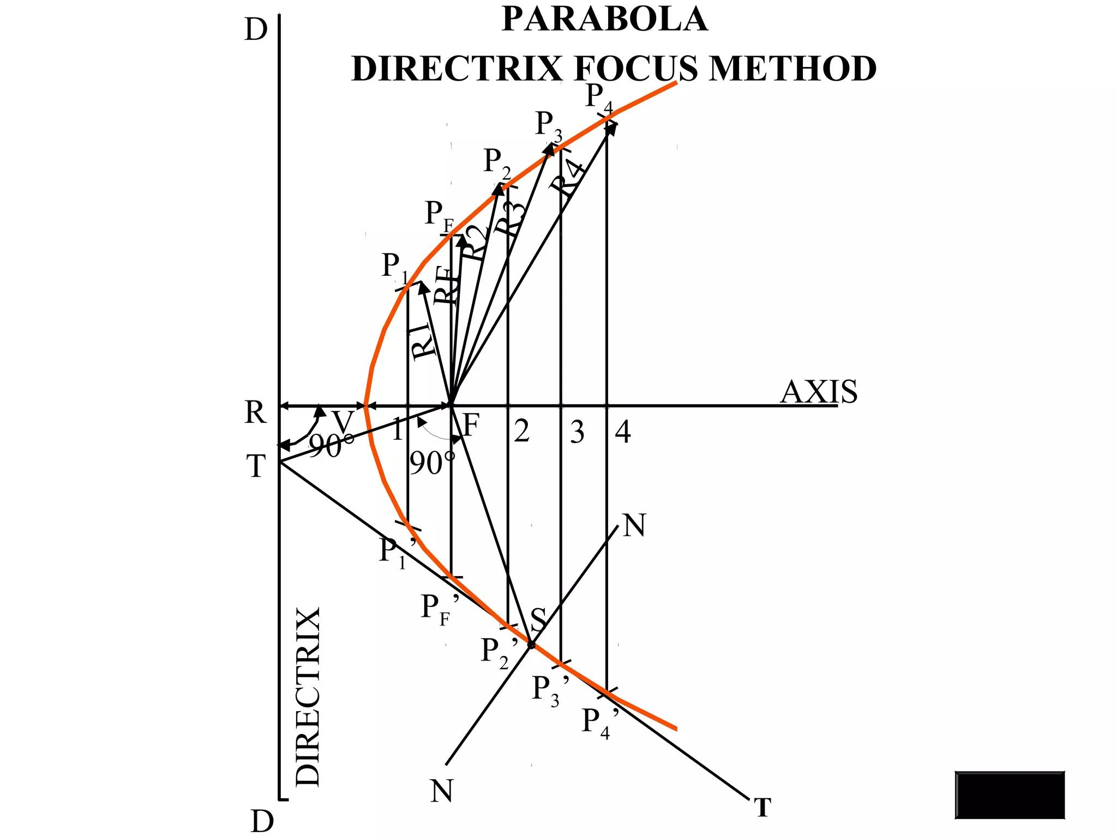
- Determine the required parabolic profile dimensions.
- Draw a straight line representing the directrix.
- Construct a perpendicular axis passing through the intended vertex and focus.
- Mark the focus $F$ at the required distance from the directrix.
- Locate the vertex halfway between the focus and the directrix along the axis.
- Fix a pin at the focus.
- Position a T-square or straightedge parallel to the directrix.
- Attach a suitable string arrangement between the focus and the drawing guide.
- Place a pencil against the guide while keeping the string taut.
- Move the guide while maintaining the string's tension and the pencil's contact with its edge.
- Trace the parabolic profile on both sides of the axis.
- Verify the symmetry and dimensions of the resulting parabola.
- Cut out the profile and use it to construct a paraboloid by rotational symmetry.
The focus-directrix and string-and-guide methods are established geometric methods for drawing a parabola.

Method 4: Constructing a Paraboloid Using Circular Templates
# Source: AI Source: Provided by: [Data Path: Persons Table -> ID Column: 1, Name_En Column: Motasem Essam] -> From: [ChatGPT] on [7/25/2026]
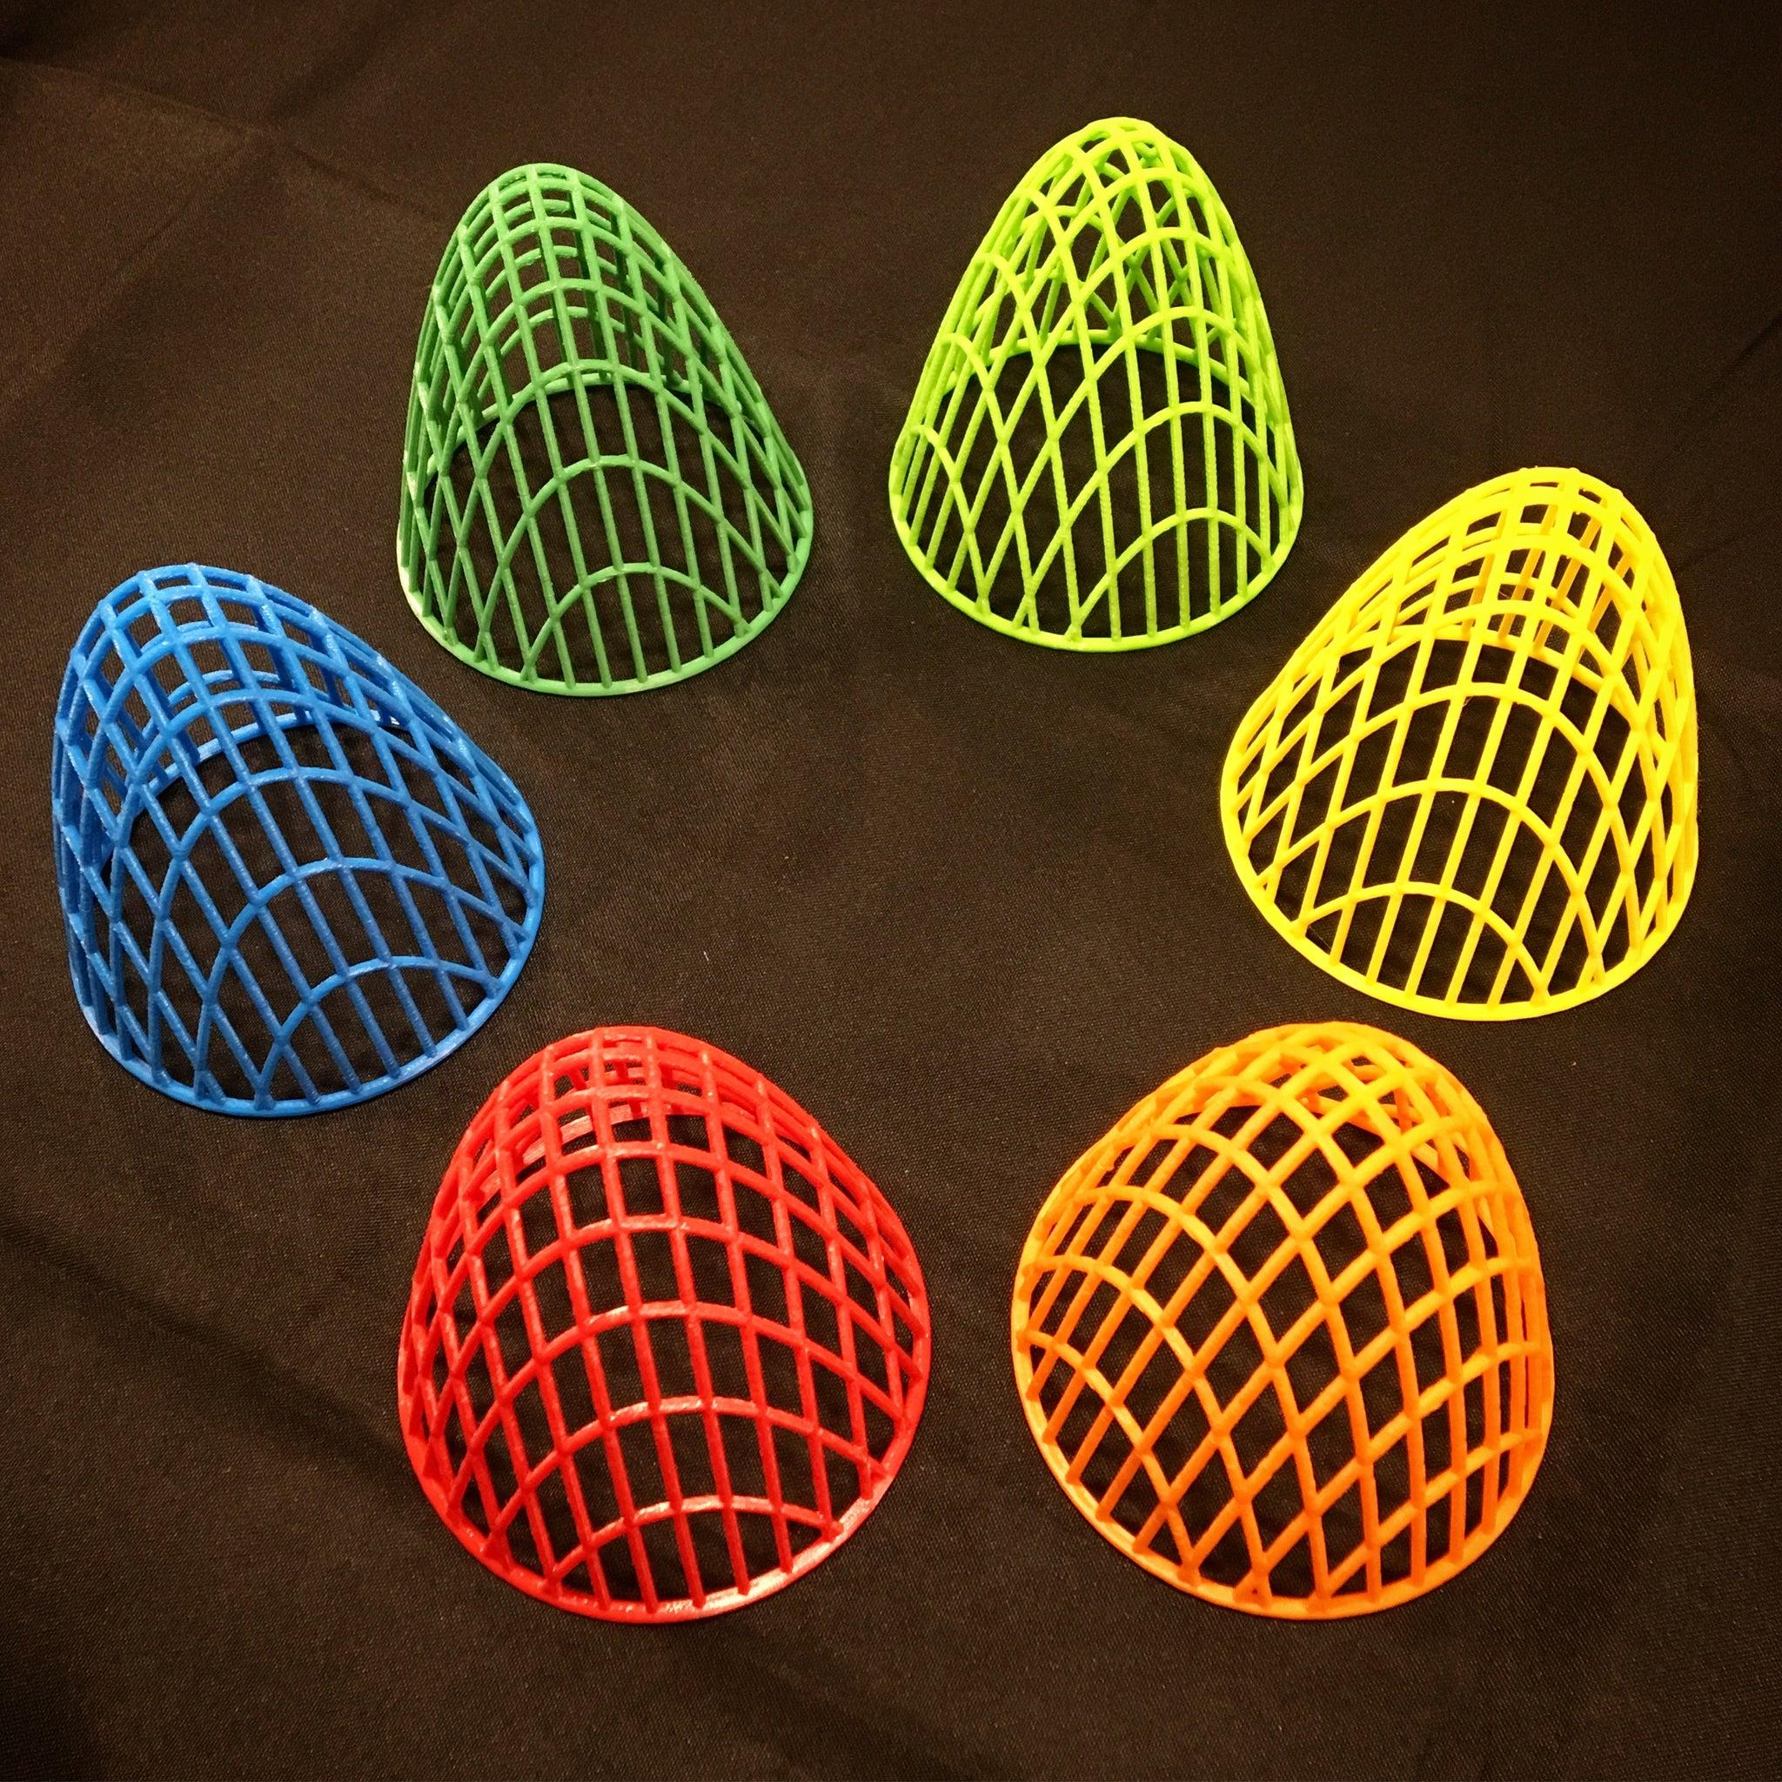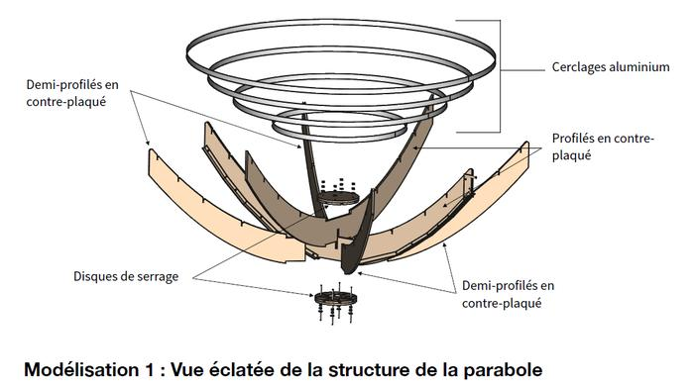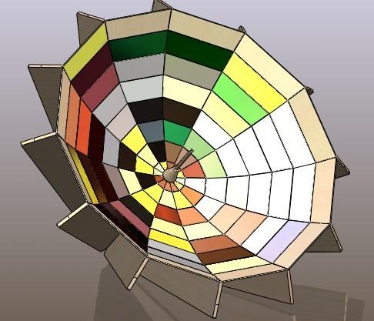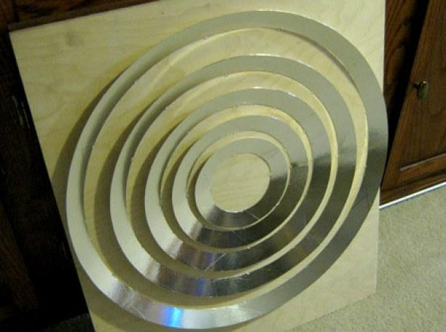
- Determine the required diameter and depth.
- Construct the parabolic side profile using geometric instruments.
- Draw the central axis through the vertex.
- Divide the profile's height into equal intervals.
- Measure the distance from the central axis to the parabolic boundary at each interval.
- Use these measurements as the radii of the circular templates.
- Draw the corresponding circles using a compass.
- Cut out the circular templates from cardboard, foam, or another suitable material.
- Arrange the templates perpendicular to the central axis.
- Align their centers along the same axis.
- Position the sections from the vertex toward the wider opening.
- Join the sections using adhesive or a central support.
- Shape and smooth the boundaries to produce an approximate paraboloid.

Method 5: Constructing an Elliptic Paraboloid Using Elliptical Cross-Sections
# Source: AI Source: Provided by: [Data Path: Persons Table -> ID Column: 1, Name_En Column: Motasem Essam] -> From: [ChatGPT] on [7/25/2026]
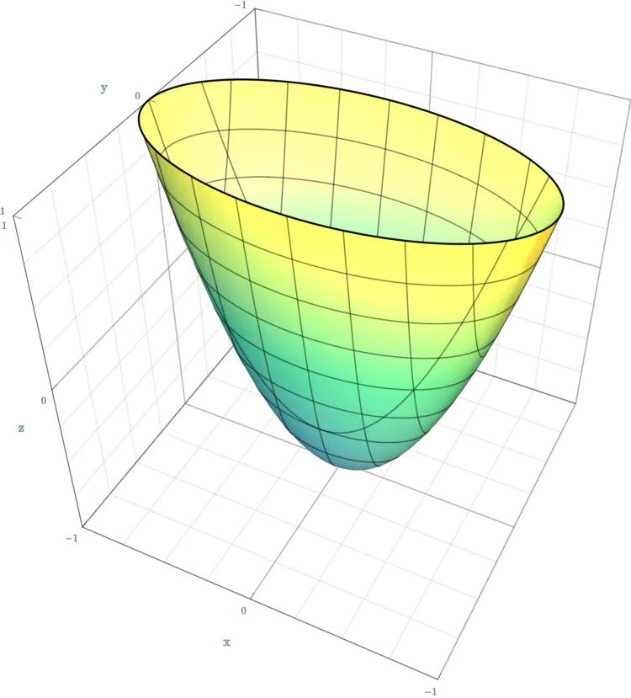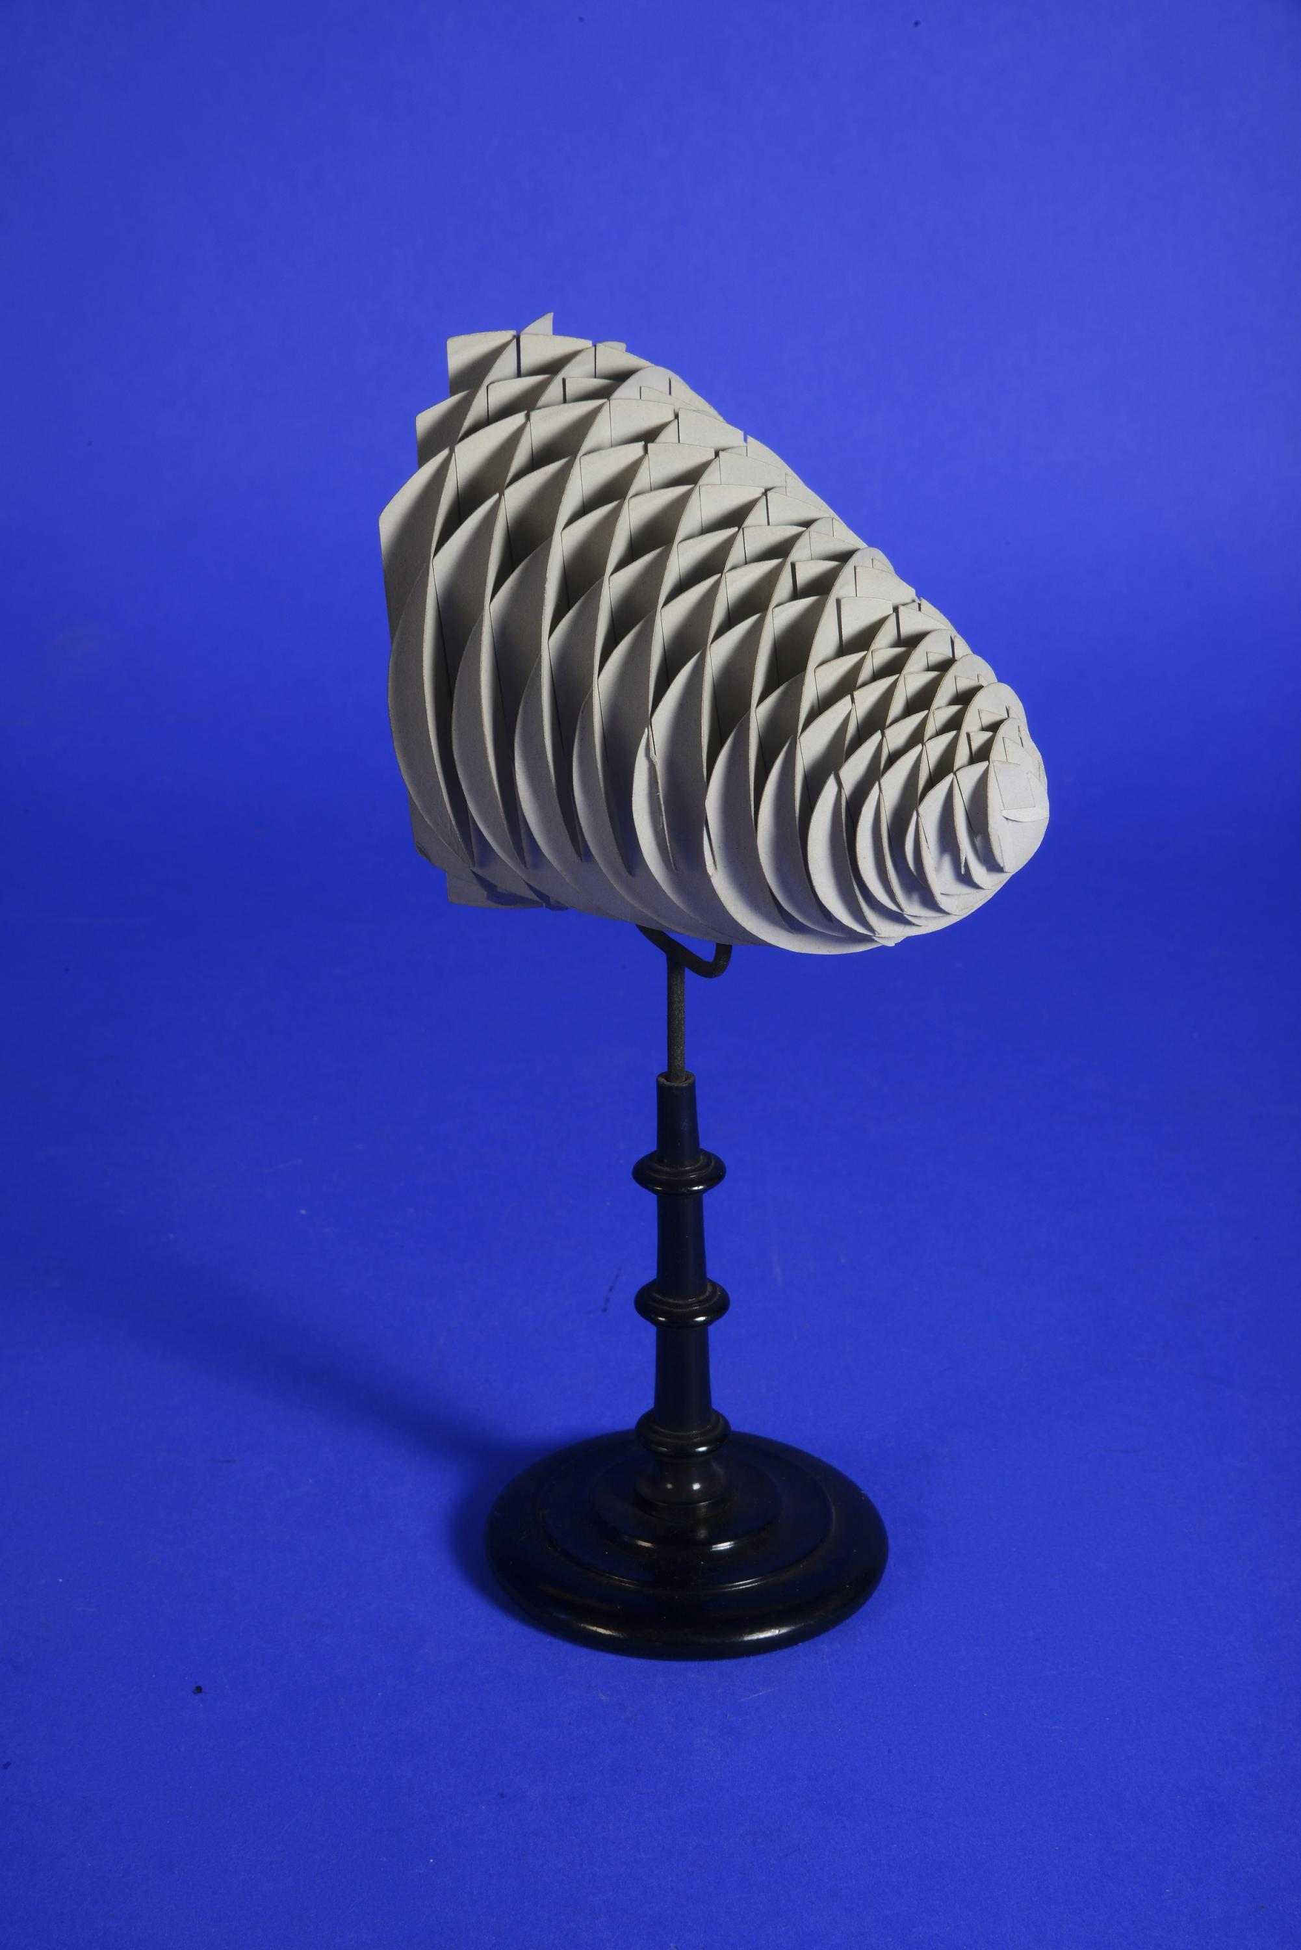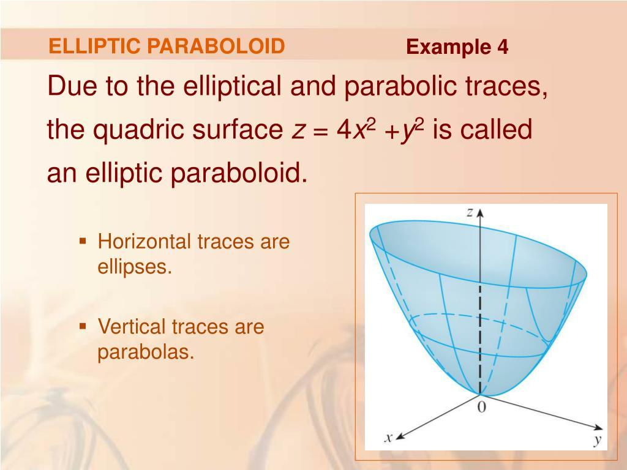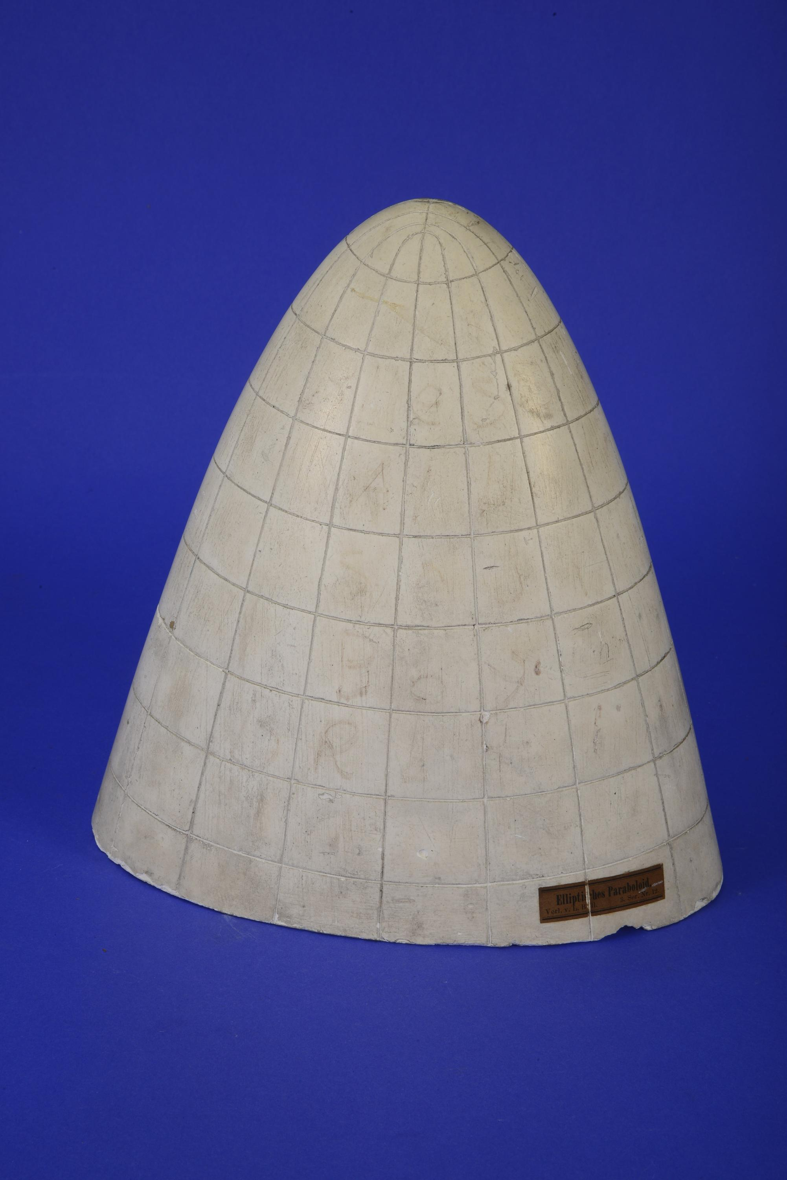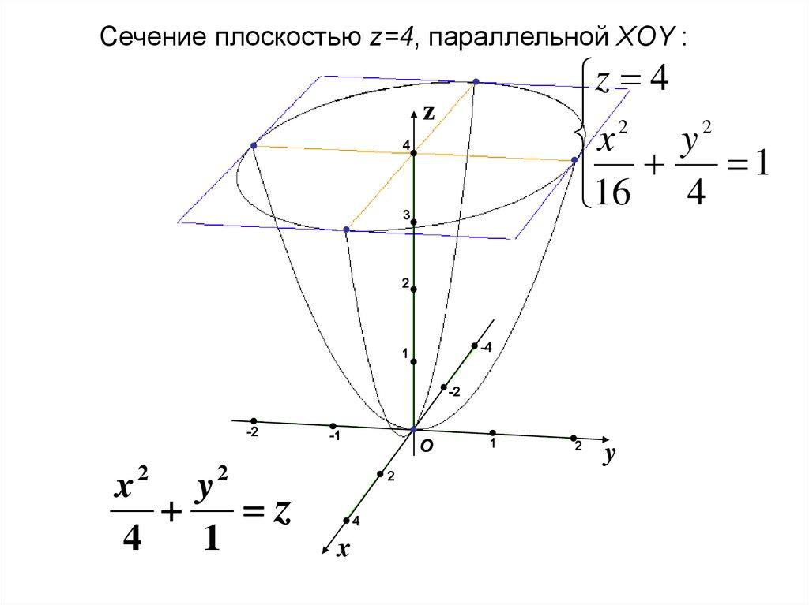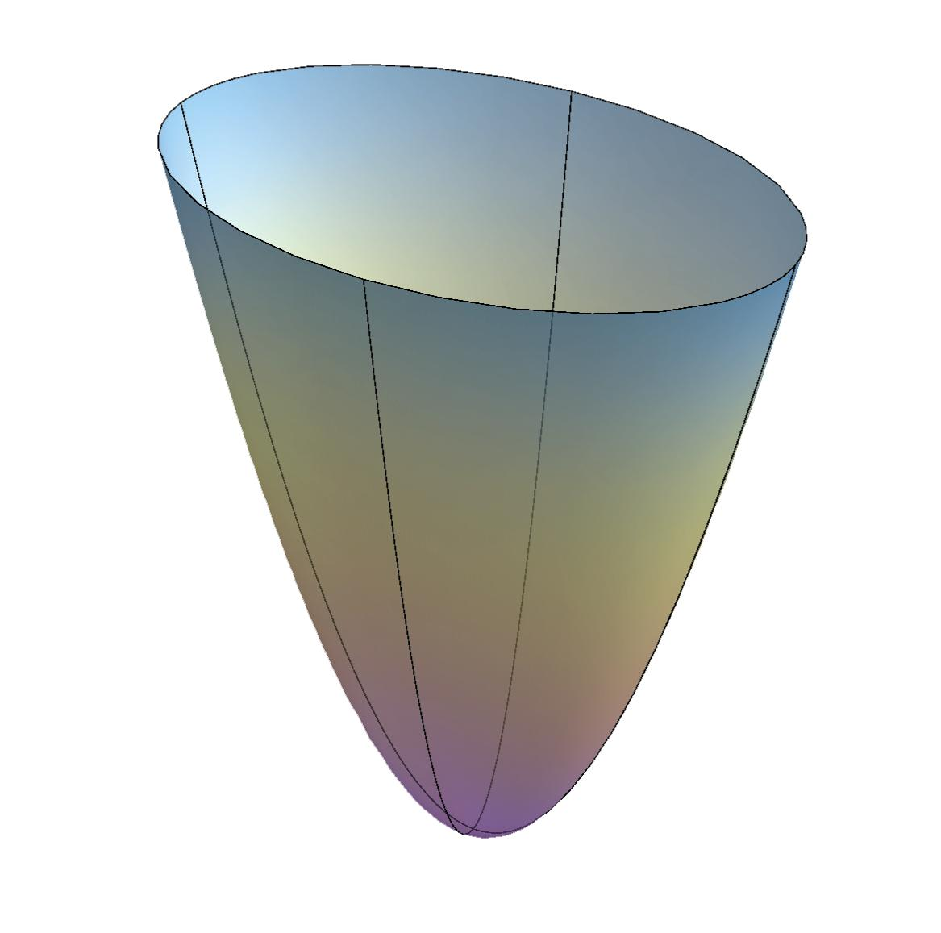
- Determine the required elliptic paraboloid's height and two opening dimensions.
- Draw a vertical axis representing its axis of symmetry.
- Construct the two perpendicular principal directions of the opening.
- Divide the height into several equal intervals.
- Draw perpendicular reference planes through the division points.
- Determine the major and minor semi-axis lengths of each elliptical cross-section.
- Construct each ellipse using an ellipsograph, elliptical trammel, or compass-based geometric construction.
- Cut the elliptical sections from cardboard, foam, or another suitable material.
- Arrange the sections perpendicular to the vertical axis.
- Align their centers along the axis.
- Position the smallest section near the vertex and progressively larger sections toward the opening.
- Join the sections using adhesive or a central support.
- Smooth the outer boundaries to approximate a continuous elliptic paraboloid.
Note: An elliptic paraboloid has elliptical horizontal cross-sections. These sections are circular only when the two opening dimensions are equal.

Method 6: Constructing a Paraboloid Using a Wire-Frame Structure
# Source: AI Source: Provided by: [Data Path: Persons Table -> ID Column: 1, Name_En Column: Motasem Essam] -> From: [ChatGPT] on [7/25/2026]
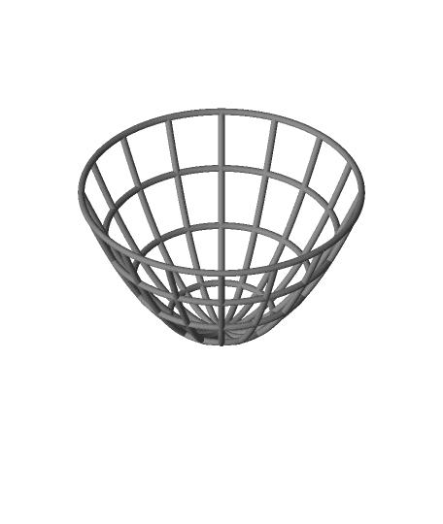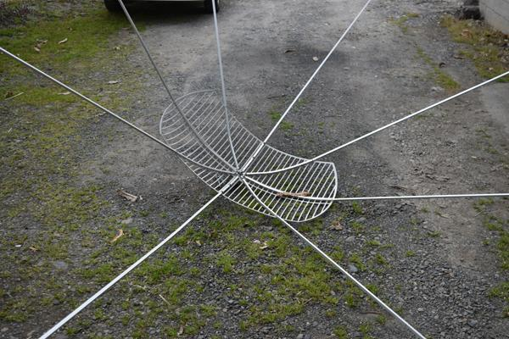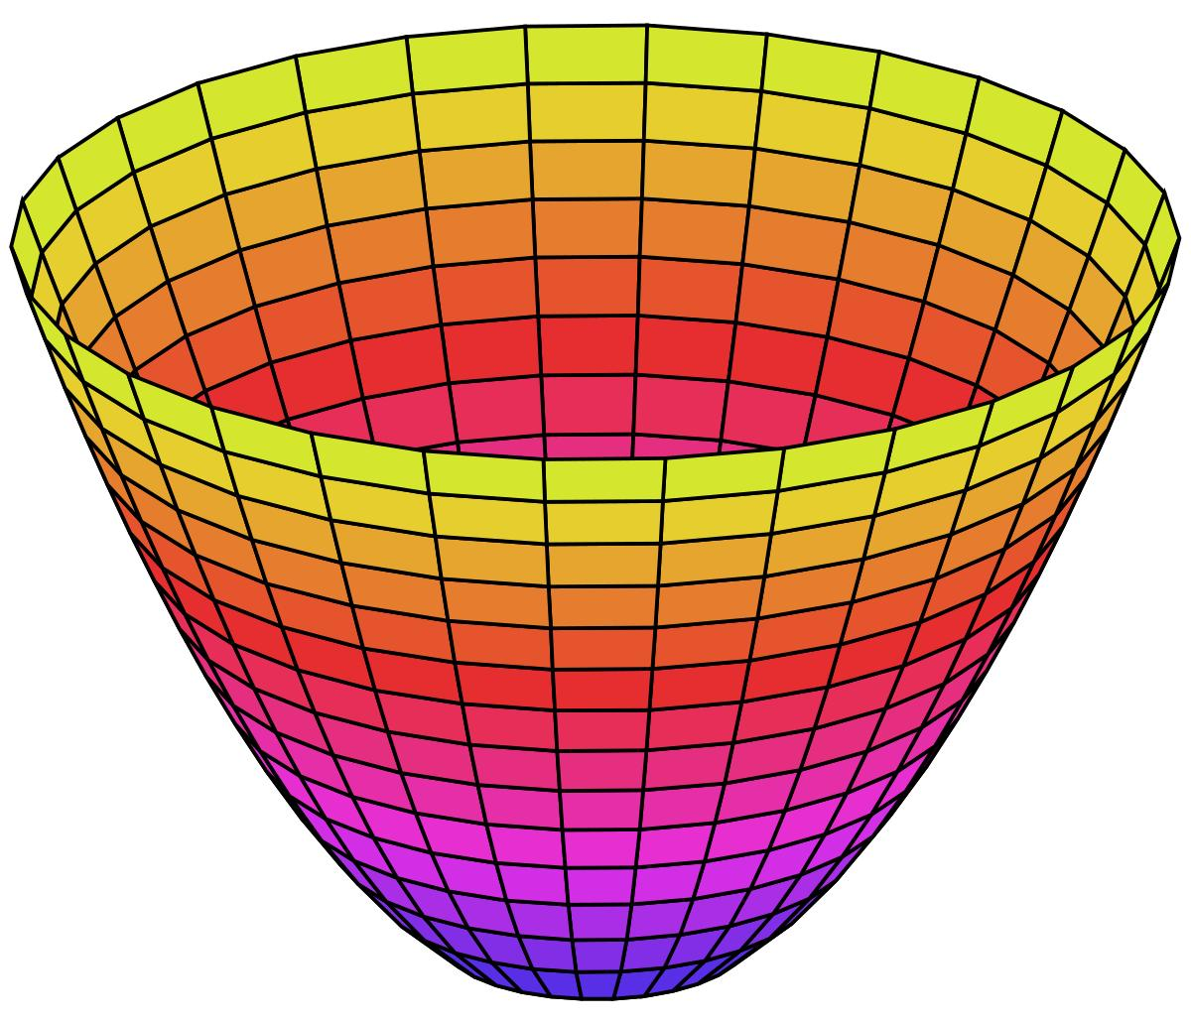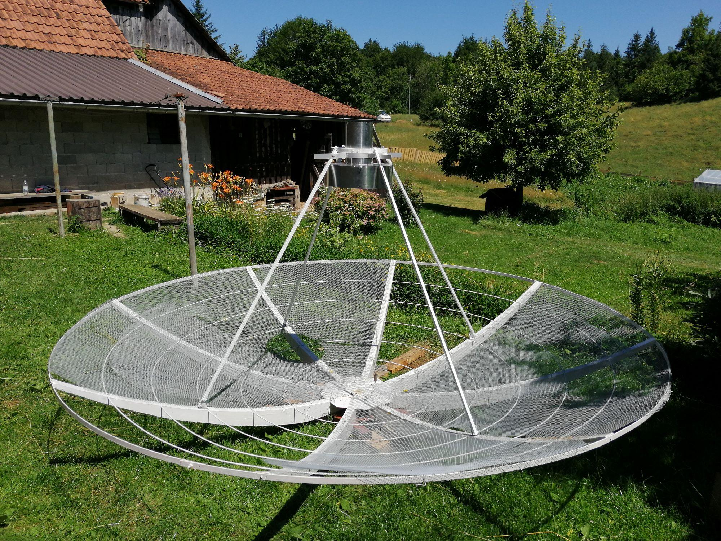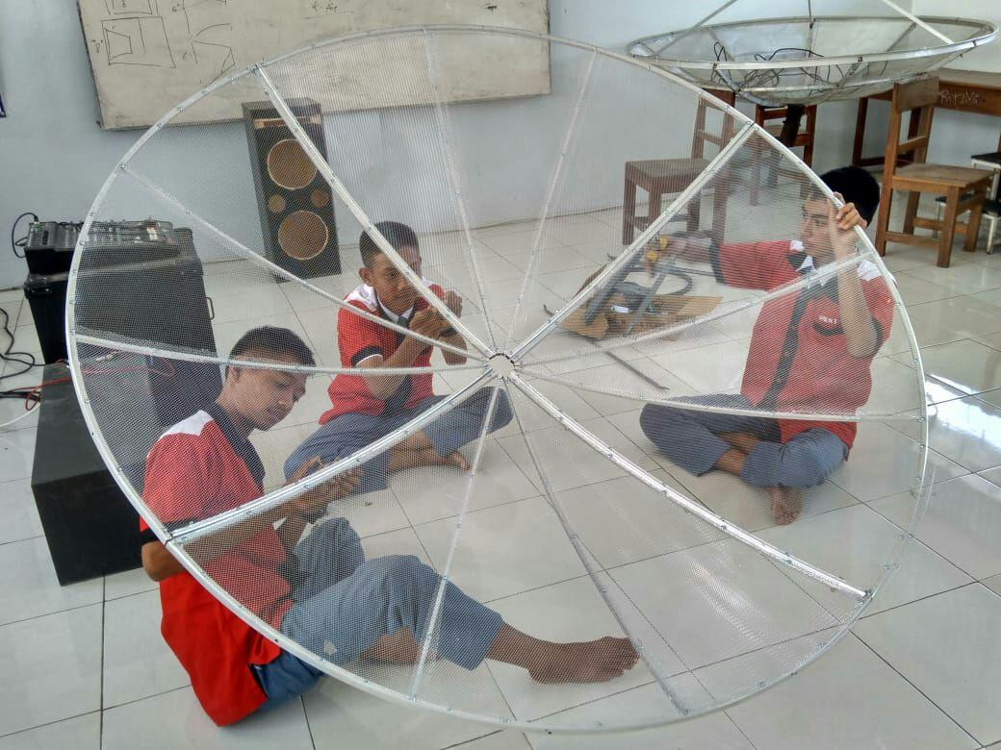
- Determine the required paraboloid's diameter and depth.
- Draw the central axis and the circular boundary of the opening.
- Construct the parabolic side profile using the focus-directrix method.
- Divide the circular opening into equal angular sections using a protractor.
- Mark corresponding positions around the circular boundary.
- Bend flexible wire into parabolic ribs following the constructed profile.
- Position each rib radially from the central axis toward the circular boundary.
- Attach all ribs to a central supporting structure.
- Connect adjacent ribs using circular or curved supporting wires.
- Add additional supports to maintain the intended parabolic shape.
- Check the symmetry and dimensions of the structure.
- Secure the intersections using suitable fasteners or adhesive.
- Cover the frame with a suitable flexible material if a continuous surface is required.

Method 7: Constructing a Paraboloid Using a Mold
# Source: AI Source: Provided by: [Data Path: Persons Table -> ID Column: 1, Name_En Column: Motasem Essam] -> From: [ChatGPT] on [7/25/2026]
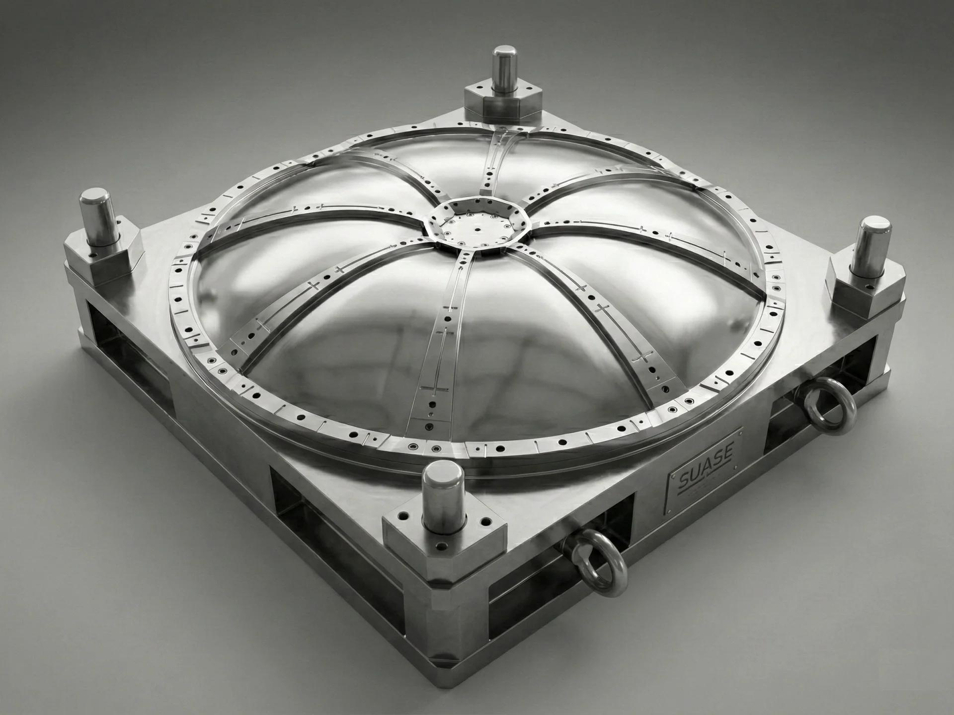
- Determine the required paraboloid diameter and depth.
- Prepare a mold with an internal surface matching the intended paraboloidal profile.
- Verify the mold's dimensions using measuring instruments.
- Check the symmetry of the mold around its central axis.
- Secure the mold in the required position.
- Prepare a suitable modeling or casting material.
- Fill or apply the material evenly over the mold.
- Ensure that the material follows the parabolic surface.
- Allow the material to set or harden.
- Remove the mold, if it is designed to be removable.
- Smooth the surface and refine its boundaries.
- Measure the opening diameter and depth to verify the finished paraboloid.

Method 8: Constructing a Hyperbolic Paraboloid Using Straightedge and Ruler-Based Construction
# Source: AI Source: Provided by: [Data Path: Persons Table -> ID Column: 1, Name_En Column: Motasem Essam] -> From: [ChatGPT] on [7/25/2026]
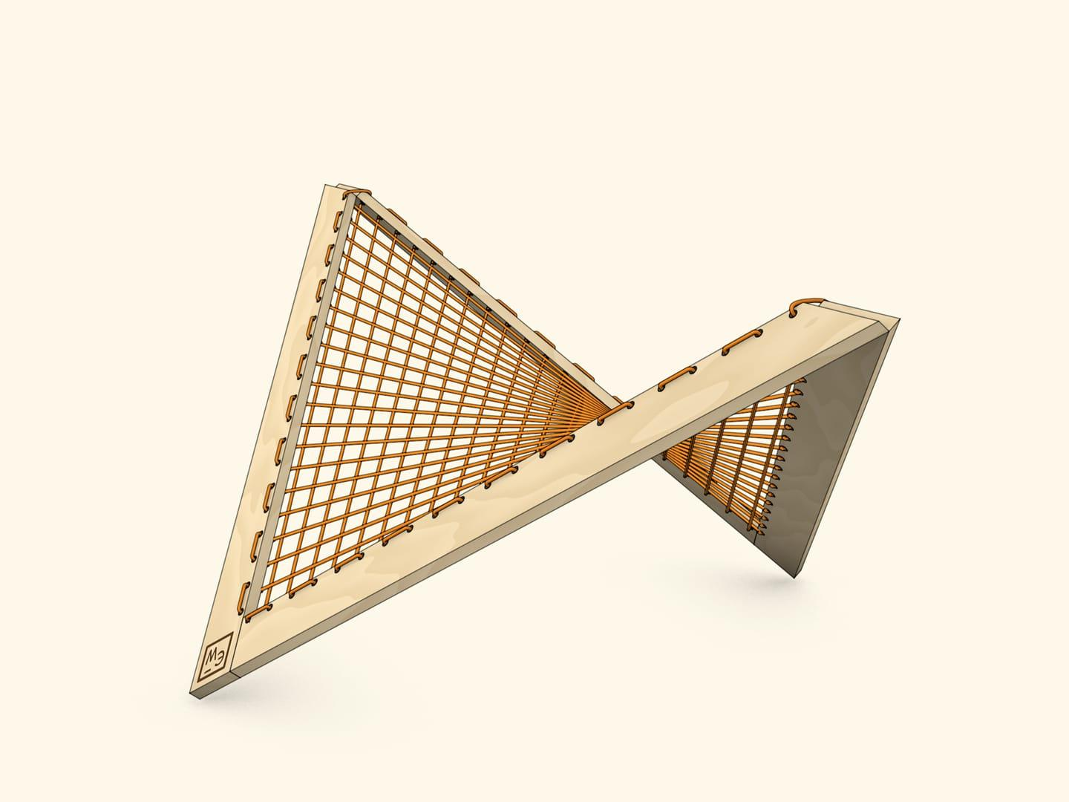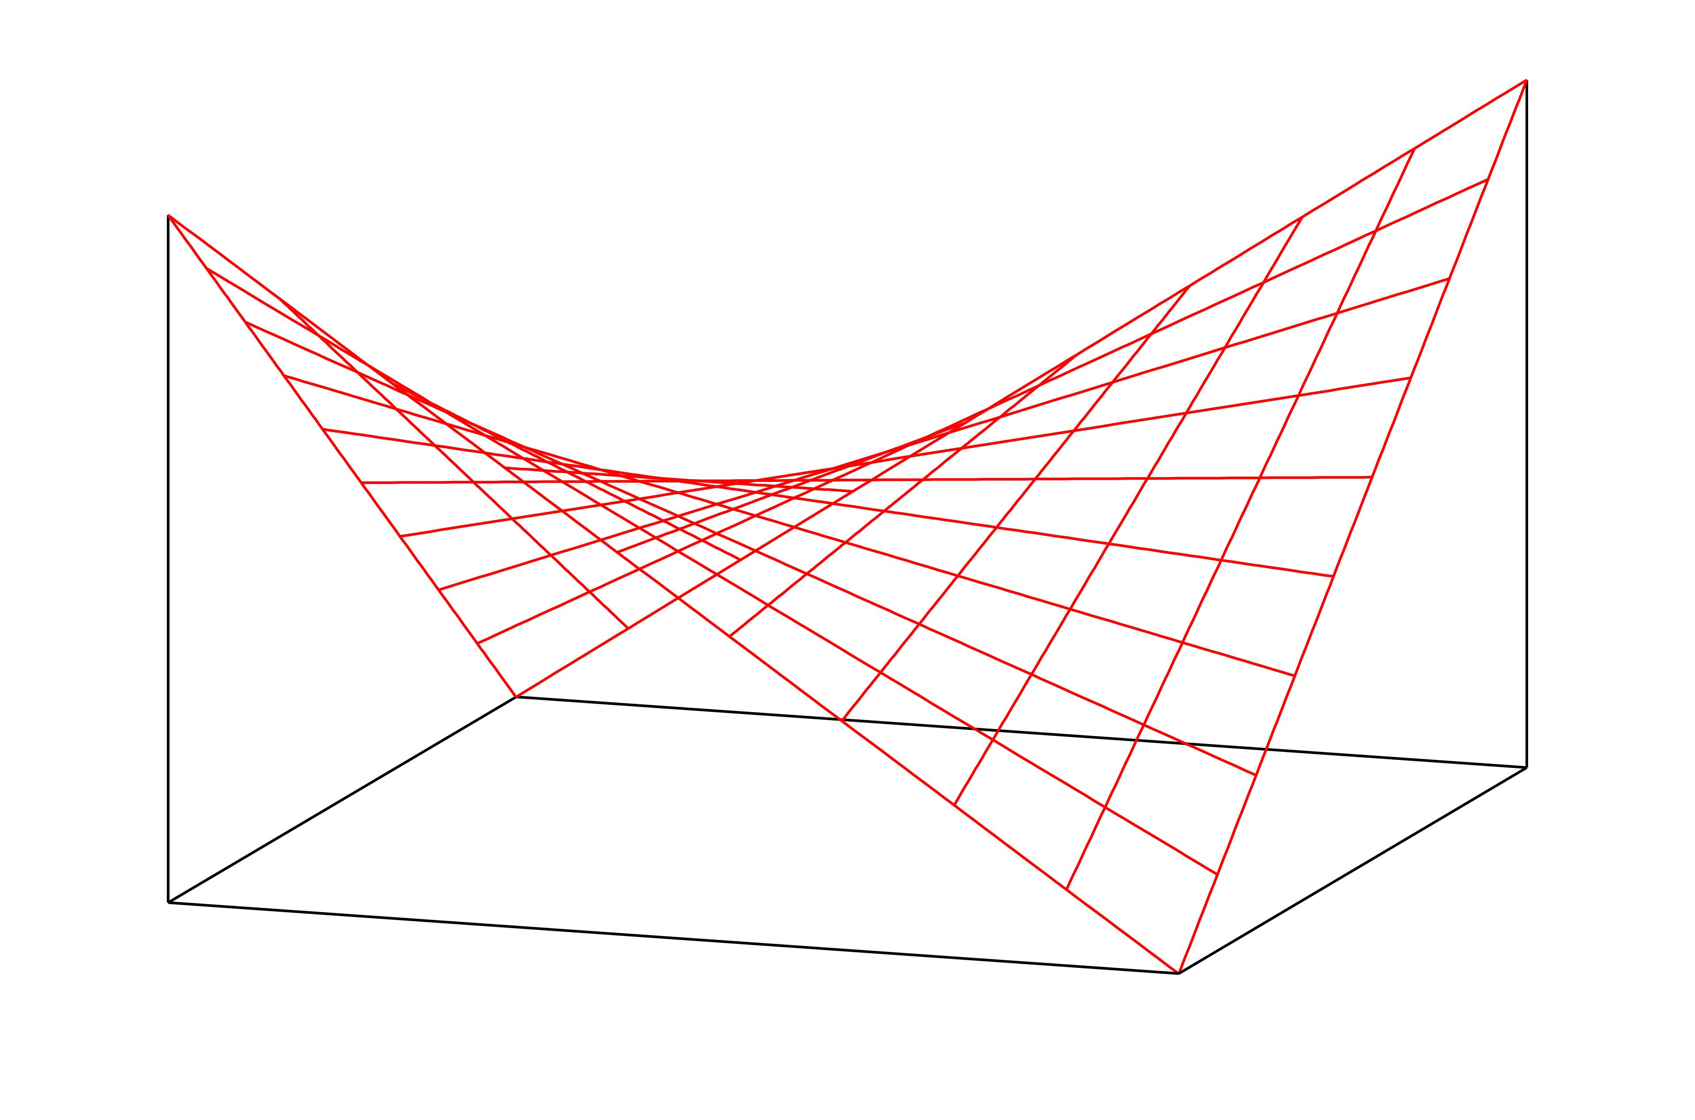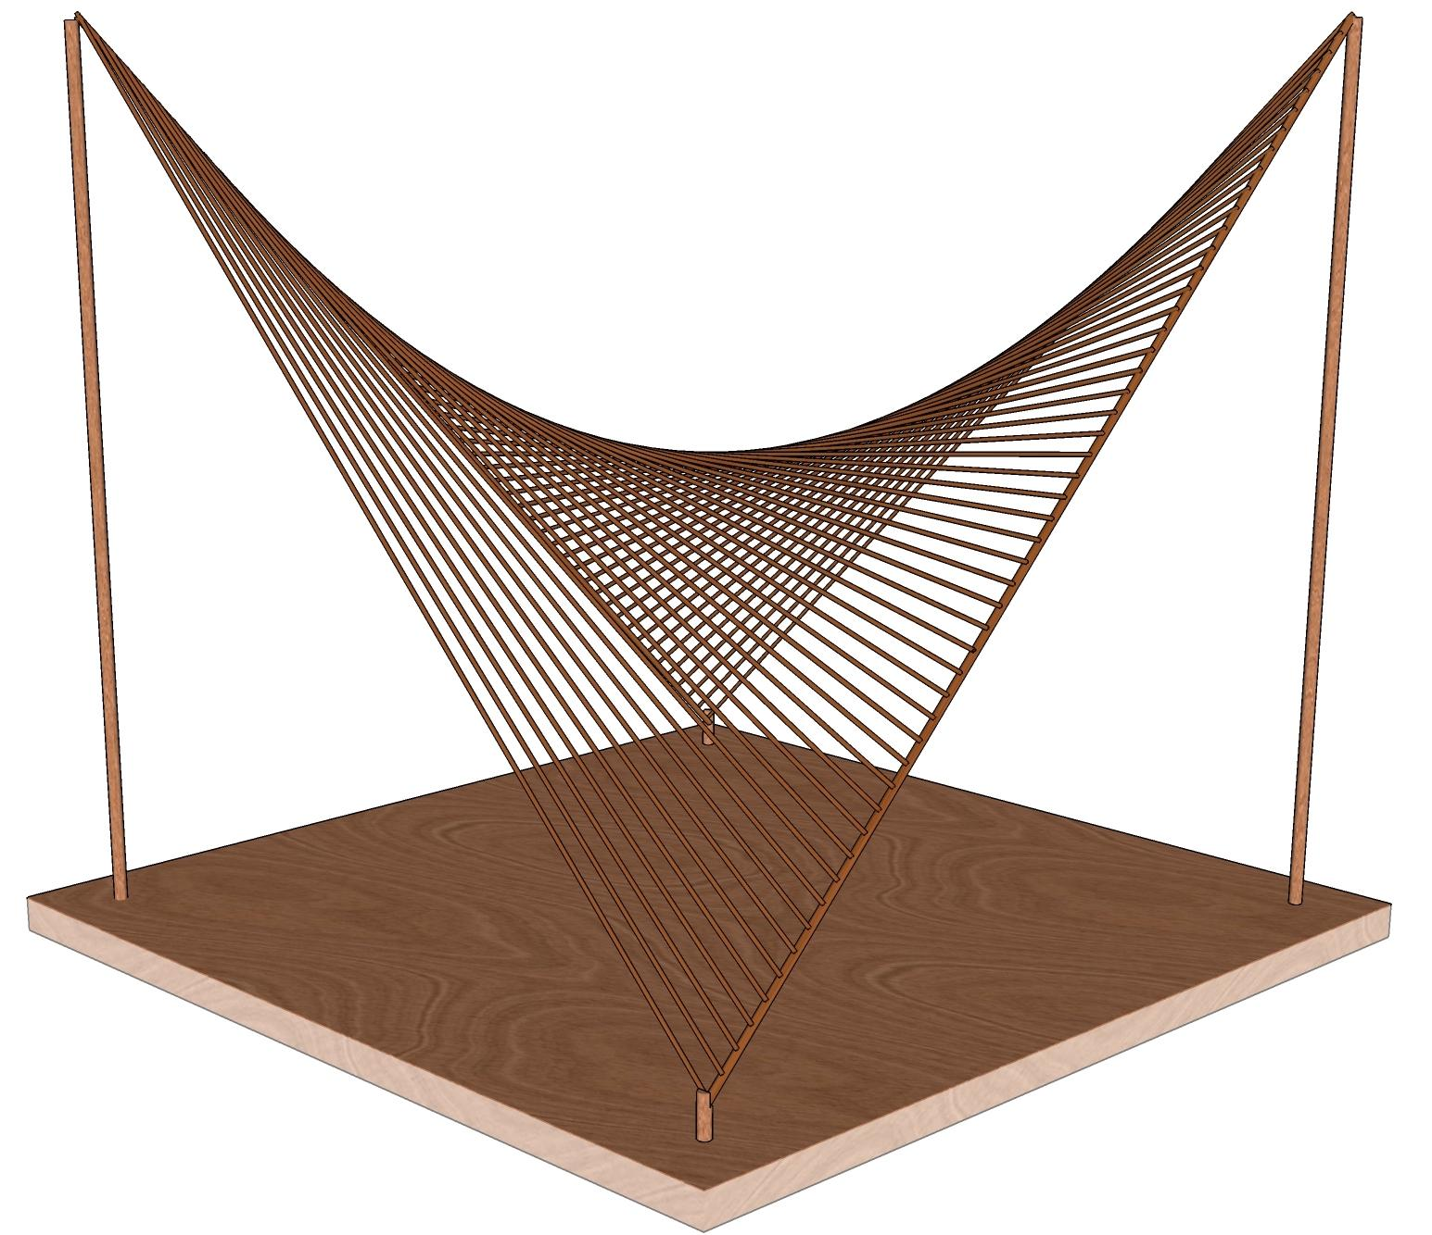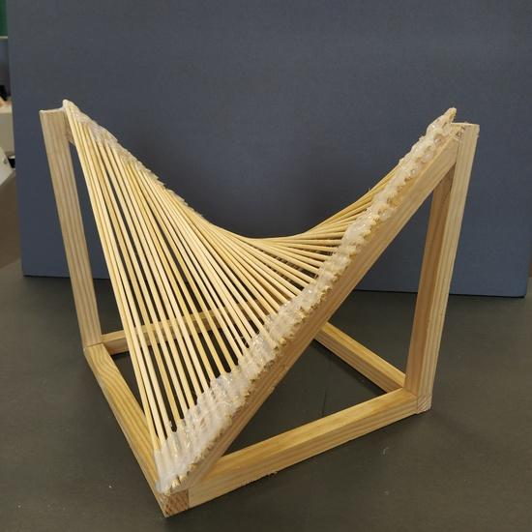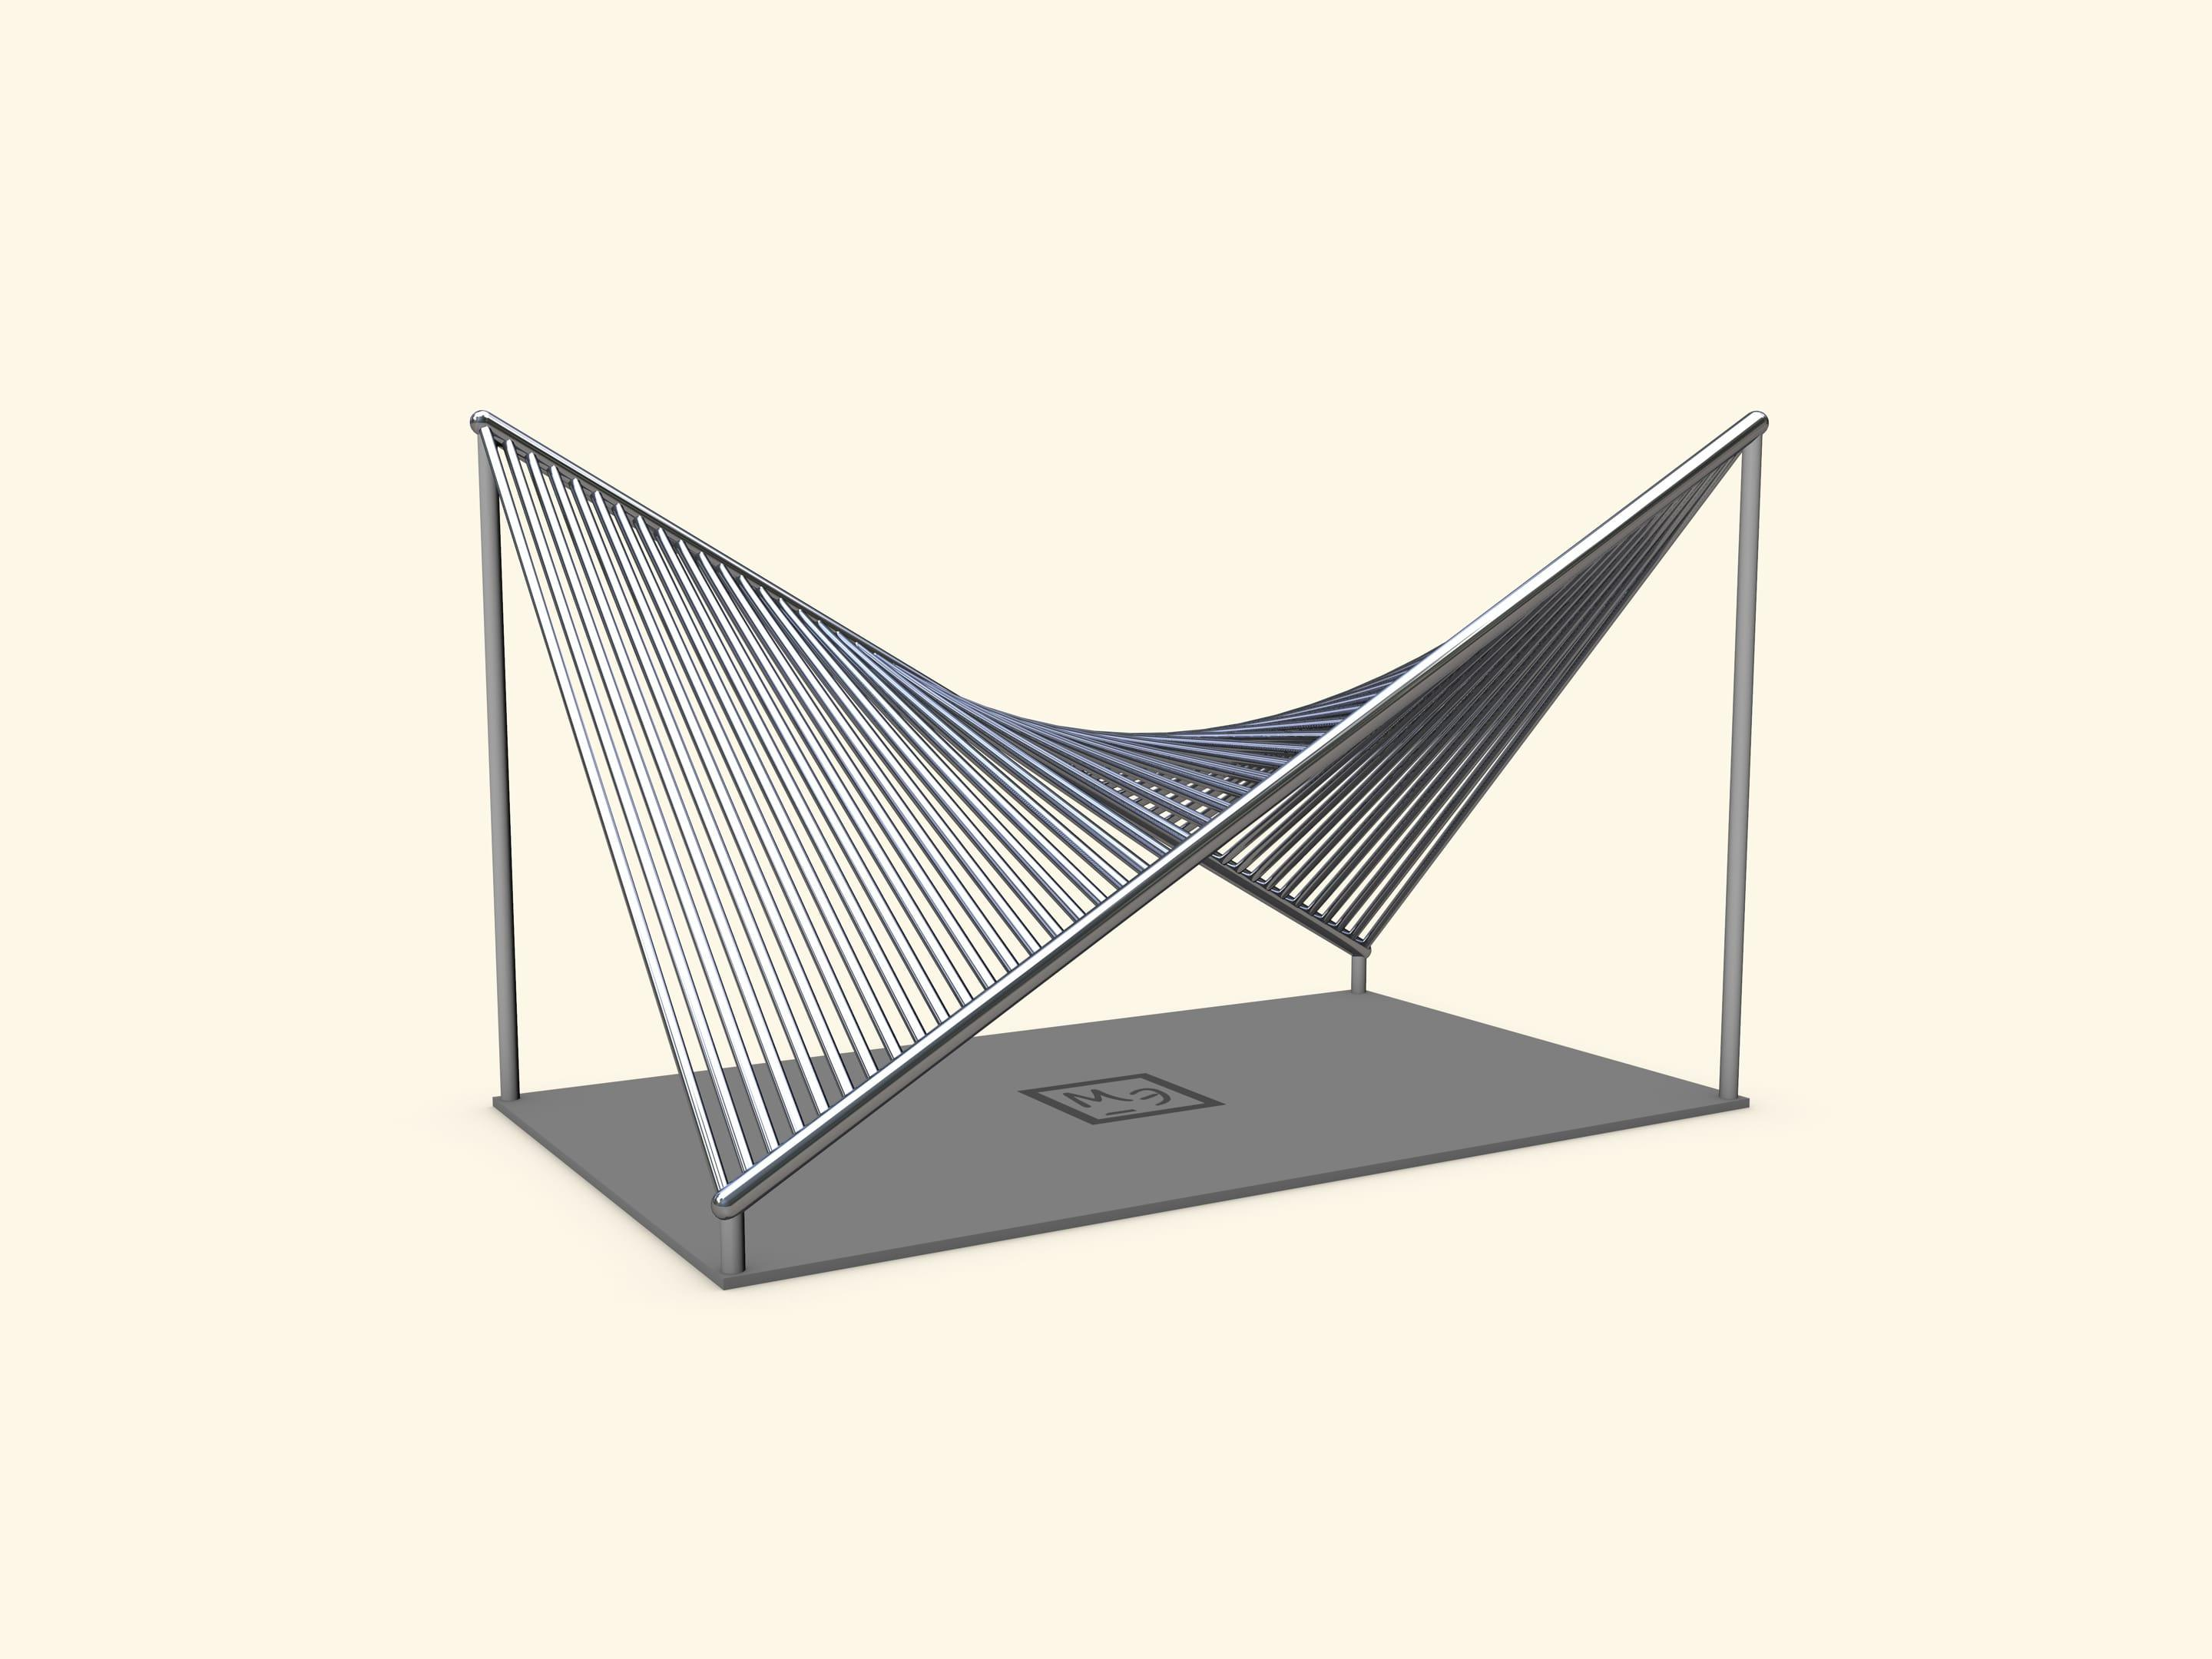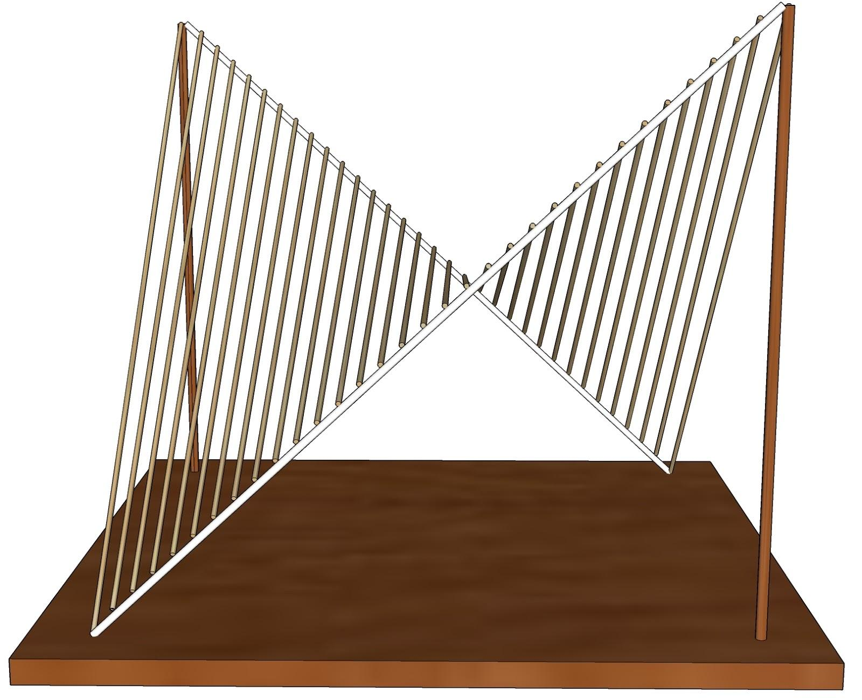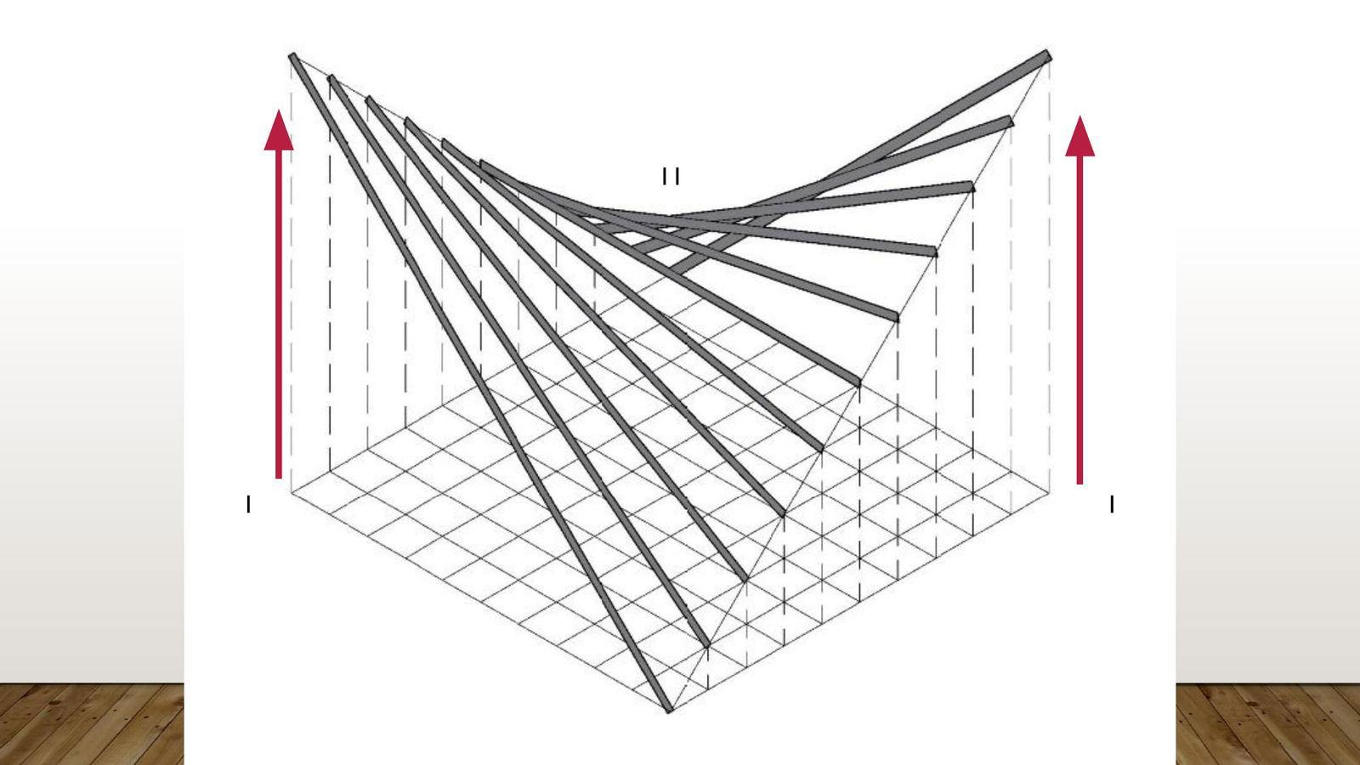
- Determine the required width, length, and height difference of the saddle-shaped surface.
- Draw a rectangular boundary representing the surface's plan.
- Mark the four corner points at the required heights.
- Construct the two perpendicular principal directions.
- Mark intermediate points along the opposite boundary edges.
- Connect corresponding points using straight reference lines.
- Repeat the construction with a second family of straight lines crossing the first family.
- Prepare straight rods or flexible structural members according to the constructed lines.
- Assemble the rods to form the saddle-shaped surface.
- Connect the intersections and secure the boundary supports.
- Verify the saddle shape and symmetry.
Note: A hyperbolic paraboloid is a different type of paraboloid from a circular paraboloid. It has a saddle-shaped surface and is a ruled surface that can be constructed using two families of straight lines. It is not generated by rotating a parabola around an axis.

Mathematical Reference
# Source: AI Source: Provided by: [Data Path: Persons Table -> ID Column: 1, Name_En Column: Motasem Essam] -> From: [ChatGPT] on [7/25/2026]
For a circular paraboloid with vertex at the origin and axis along its height:
$$z=\frac{x^{2}+y^{2}}{4f}$$
where $f$ is the focal length.
For a horizontal circular cross-section at height $z$:
$$r=2\sqrt{fz}$$
For an elliptic paraboloid:
$$z=\frac{x^{2}}{4a}+\frac{y^{2}}{4b}$$
For a hyperbolic paraboloid:
$$z=\frac{x^{2}}{4a}-\frac{y^{2}}{4b}$$
These equations describe the geometric profiles; the construction procedures above use physical instruments and geometric measurements rather than coordinate-based construction.
Construction note:
- Included: Instrument-Based Construction using compasses, rulers, protractors, set squares, T-squares, strings, geometric templates, rotational frames, molds, and physical model assembly.
- Not Included: Coordinate-Based Construction using Cartesian coordinates, coordinate equations, or vertex-coordinate calculations.
- Rotating a parabola around its axis produces a circular paraboloid.
- Elliptical cross-sections produce an elliptic paraboloid.
- Two intersecting families of straight lines can construct a hyperbolic paraboloid.
Sources:
- ScienceDirect – Geometry for Naval Architects: The Parabola and Paraboloid — Parabola rotation and paraboloid geometry.
- A Descriptive Treatise on Mathematical Drawing Instruments — Instruments and string-based parabola construction.
- Descriptive Geometry — Focus-directrix and continuous-motion construction.
- Bharat Skills – Engineering Drawing — Practical geometric construction of parabolas.

Important Characteristics
# Source: AI Source: Provided by: [Data Path: Persons Table -> ID Column: 1, Name_En Column: Motasem Essam] -> From: [ChatGPT] on [7/25/2026]
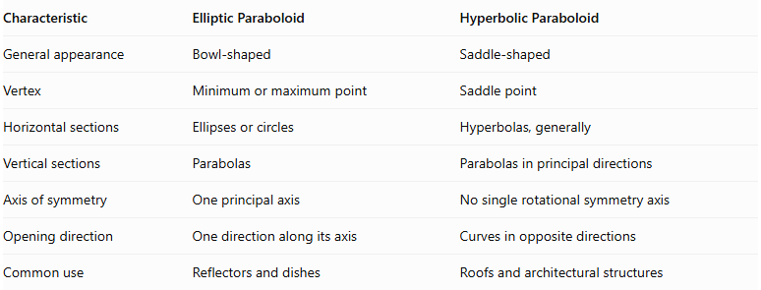
Characteristic | Elliptic Paraboloid | Hyperbolic Paraboloid
General appearance | Bowl-shaped | Saddle-shaped
Vertex | Minimum or maximum point | Saddle point
Horizontal sections | Ellipses or circles | Hyperbolas, generally
Vertical sections | Parabolas | Parabolas in principal directions
Axis of symmetry | One principal axis | No single rotational symmetry axis
Opening direction | One direction along its axis | Curves in opposite directions
Common use | Reflectors and dishes | Roofs and architectural structures

Comparison with Related Geometric Solids and Surfaces
# Source: AI Source: Provided by: [Data Path: Persons Table -> ID Column: 1, Name_En Column: Motasem Essam] -> From: [ChatGPT] on [7/25/2026]
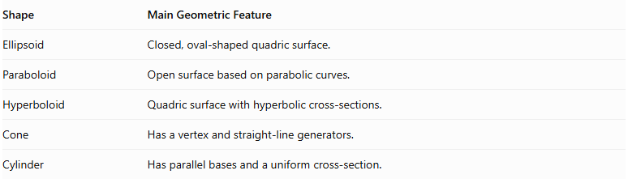
Shape | Main Geometric Feature
Ellipsoid | Closed, oval-shaped quadric surface.
Paraboloid | Open surface based on parabolic curves.
Hyperboloid | Quadric surface with hyperbolic cross-sections.
Cone | Has a vertex and straight-line generators.
Cylinder | Has parallel bases and a uniform cross-section.
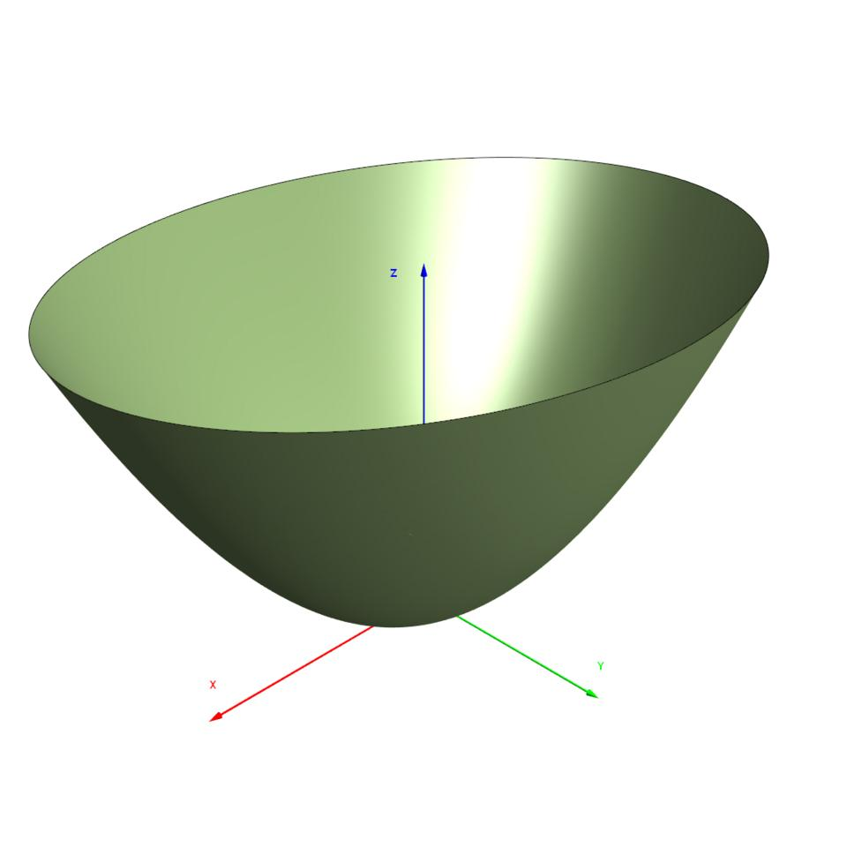

Applications
# Source: AI Source: Provided by: [Data Path: Persons Table -> ID Column: 1, Name_En Column: Motasem Essam] -> From: [ChatGPT] on [7/25/2026]
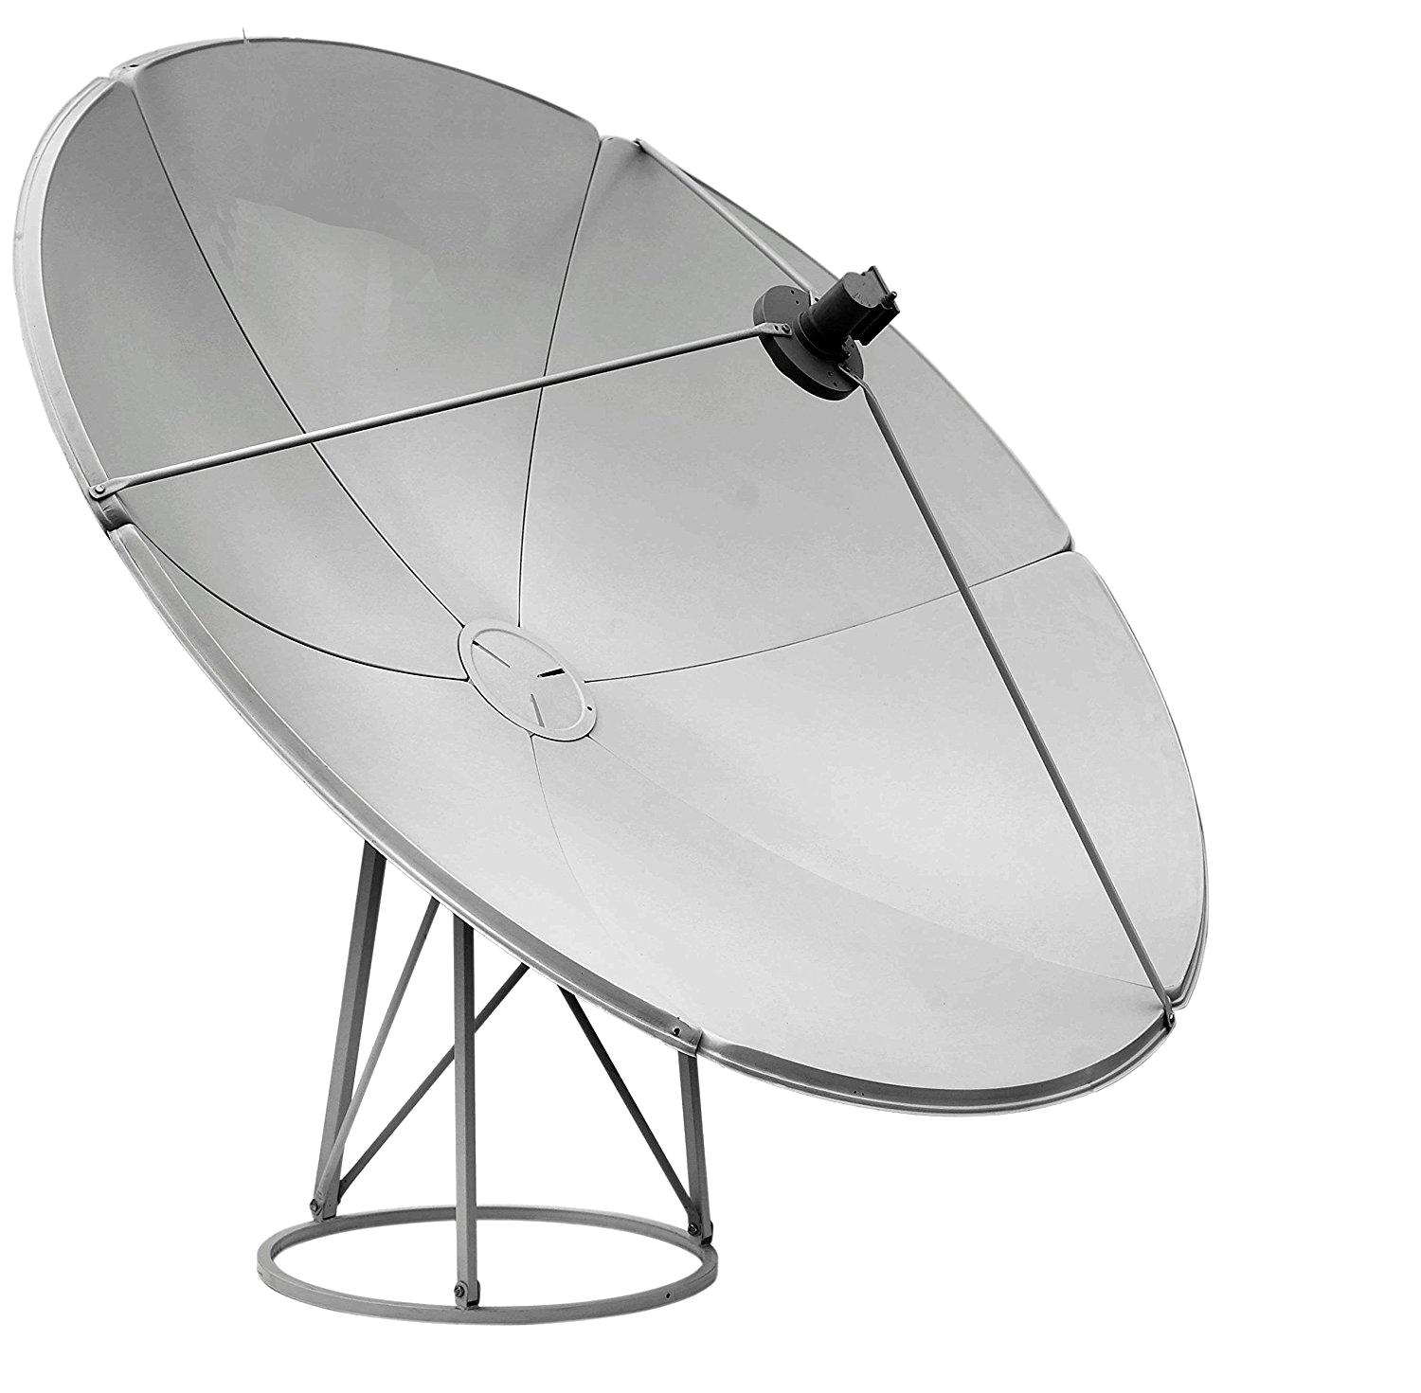
Satellite Dishes
Circular paraboloids reflect incoming electromagnetic waves toward a focal point.
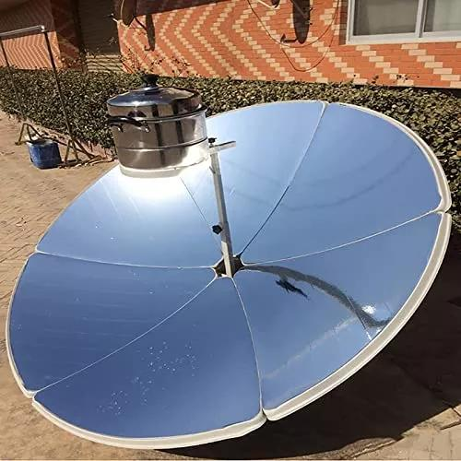
Solar Reflectors
Paraboloidal surfaces concentrate sunlight at a focal point.

Architecture
Hyperbolic paraboloids are used in saddle-shaped roofs and thin-shell structures.
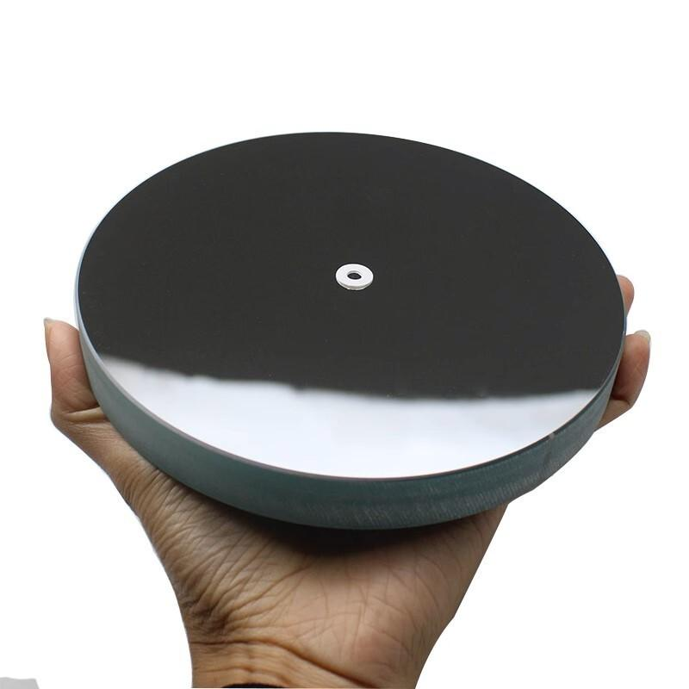
Optical Instruments
Parabolic reflectors focus parallel light rays, making them useful in telescopes and other optical systems.

Key Points
# Source: AI Source: Provided by: [Data Path: Persons Table -> ID Column: 1, Name_En Column: Motasem Essam] -> From: [ChatGPT] on [7/25/2026]
- A paraboloid is a three-dimensional quadric surface.
- Its two principal types are elliptic and hyperbolic paraboloids.
- An elliptic paraboloid has a bowl-like shape.
- A hyperbolic paraboloid has a saddle-like shape.
- The elliptic paraboloid has a vertex that is a minimum or maximum point.
- The hyperbolic paraboloid has a saddle point.
- Horizontal cross-sections of an elliptic paraboloid are ellipses or circles.
- The volume of an elliptic paraboloid segment is half the volume of an elliptical cylinder with the same base and height.

Conclusion
# Source: AI Source: Provided by: [Data Path: Persons Table -> ID Column: 1, Name_En Column: Motasem Essam] -> From: [ChatGPT] on [7/25/2026]
A paraboloid is an important three-dimensional quadric surface characterized by parabolic curvature. Its two main forms are the elliptic paraboloid, which has a bowl-like shape, and the hyperbolic paraboloid, which has a saddle-like shape. Paraboloids are important in geometry, mathematics, engineering, architecture, optics, and reflector design.

